EDA CAPSTONE PROJECT- HOTEL BOOKING

**HOTEL BOOKING ANALYSIS**

Mayank Shukla

|  |
| --- |
| **Index: -** |
| I. Abstract |
| II. Introduction |
| III. Project Goal |
| IV. Attributes |
| 1. Exploratory Data Analysis    1. Data Cleaning    2. Data Manipulation    3. Data Study |
| VI. Data Visualization |
| VII. Conclusion |
| VIII. Challenges |

# Abstract

The success factoring a profitable hotel industry has been changing over time, driven by global competition and increasingly high customer expectations. Hotels focus on customer satisfaction and to exceed customer expectations.

We have a hotel booking dataset containing information for city and resort hotels. This dataset has 32 variables with around 1,19,000 entries. The study has data recorded between 2015 to 2017 which have bookings that shows effectively arrived and bookings that were canceled.

We have a hotel booking dataset. We are using our Power Bi, Excel, SQL skills to perform EDA questions and Power BI questions and gain informative insights about factors in hotel bookings and how they affect hotel bookings.

# Introduction :-

In the hotel industry, focus is on revenue and research is on forecasting demand and predicting the needs of the customers.

Background: The background section provides context for the hotel booking analysis. It sets the stage by explaining the circumstances or events leading to the need for this analysis. This might include trends in the hospitality industry, the increasing use of online booking platforms, or changes in customer behavior. The background aims to give readers a clear understanding of the environment in which the analysis is taking place.

Example: "With the rapid growth of online travel agencies and the increasing trend of consumers relying on digital platforms for hotel reservations, the hospitality industry is undergoing significant transformations. In this dynamic landscape, understanding the patterns and factors influencing hotel bookings becomes crucial for hotel owners and managers."

B. Purpose of the Analysis: The purpose section outlines the main reason or goal of conducting the hotel booking analysis. It clarifies the problem or question that the analysis seeks to address. This could range from optimizing pricing strategies and improving customer satisfaction to identifying patterns in booking cancellations. Defining the purpose helps guide the analysis and ensures that it aligns with the broader objectives.

Example: "The primary purpose of this analysis is to gain actionable insights into hotel booking trends, customer preferences, and factors influencing booking outcomes. By leveraging data from various booking platforms and historical hotel data, we aim to uncover patterns that can inform strategic decisions for hotel management. Specifically, we intend to identify factors contributing to booking cancellations and explore opportunities for enhancing the overall booking experience."

C. Scope and Objectives: The scope and objectives section outlines the boundaries and goals of the analysis. It clarifies what aspects of the hotel booking process will be covered and what specific outcomes are expected. This section helps manage expectations and provides a roadmap for the analysis.

Example: "The scope of this analysis includes data collected from major hotel booking platforms and historical hotel records spanning the last two years. We will focus on analyzing factors such as booking patterns, customer demographics, and room demand. The primary objectives are to develop predictive models for booking cancellations, identify key customer segments, and provide actionable recommendations for hotel management to enhance their operational and marketing strategies."

This dataset has a collection of two types of hotels. The resort hotel and the city hotel. It is collected in order to predict hotel bookings and its probability of cancellation. Some attributes here are to understand what factors do bring in the revenue for the business. Some attributes show the customers preference for booking whereas some attributes show the factors leading to cancellations.

# Project Goal :-

Purpose of our study is to find the best time of year to book a hotel room. The optimal length of stay in order to get the best daily rate. Study on special requests.

This data set contains booking information for a city hotel and a resort hotel, and includes information such as when the booking was made, length of stay, the number of adults, children, and/or babies, and the number of available parking spaces, among other things. All personally identifying information has been removed from the data.

Explore and analyze the data to discover important factors that govern the

bookings.

# Attributes:-

We have a sample hotel bookings dataset. Here are its attributes:

|  |
| --- |
| * **hotel: Indicates types of Hotels**   + **City hotel**   + **Resort type** |
| * **is_canceled: Indicates the cancellation of the hotel booking**   + **Cancellation = 1**   + **No Cancellation = 0** |
| * **lead_time: Time (in days) between booking transaction and actual arrival.** |
| * **arrival_date_year: Year of arrival** |

|  |
| --- |
| * **arrival_date_month: Month of arrival** |
| * **arrival_date_week_number: week number of arrival date.** |
| * **arrival_date_day_of_month: Day of month of arrival date** |
| * **stays_in_weekend_nights: No. of weekend nights stayed in a hotel** |
| * **stays_in_week_nights: No. of weeknights stayed in a hotel** |
| * **adults: No. of adults in a single booking record.** |
| * **children: No. of children in a single booking record.** |
| * **babies: No. of babies in single booking record.** |
| * **meal: Type of meal chosen**   + **BB:- bed and breakfast**   + **HB:-Half board (Breakfast and dinner)**   + **FB:- Full Board (All meals included)**   + **SC:- Self catering (No meals Included)** |
| * **country: Country of origin. Categories are represented in the ISO 3155–3:2013 format.** |
| * **Market_segment: market segment for booking**   + **Aviation**   + **Complimentary**   + **Corporate**   + **Direct**   + **Groups**   + **Online (TA)**   + **Offline (TA/TO)** |
| * **Distribution_channel: Via which medium booking**   + **Corporate**   + **Direct**   + **GDS: - Global Distribution System**   + **TA/TO: - Travel Agent/Operator** |
| * **is_repeated_guest:**   + **0 for new customer** |

|  |
| --- |
| * **1 for repeated customer** |
| * **previous_cancellations: No. of previous canceled bookings.** |
| * **previous_bookings_not_canceled: No. of previous non-canceled bookings.** |
| * **reserved_room_type: Room type reserved by a customer.** |
| * **assigned_room_type: Room type assigned to the customer.** |
| * **booking_changes: No. of booking changes done by customers** |
| * **deposit_type: Type of deposit at the time of making a booking**   + **No deposit**   + **Refundable**   + **No refund** |
| * **agent: Id of agent for booking** |
| * **company: Id of the company making a booking** |
| * **days_in_waiting_list: No. of days in waiting to book** |
| * **customer_type: Type of customer**   + **Contract: - bookings done by the contract**   + **Group: - Group booking**   + **Transient: - Customer staying for shorter period**   + **Transient-Party: - Group of customers staying for a shorter period** |
| * **adr: Average Daily rate of hotels.** |
| * **required_car_parking_spaces: No. of car parking preferred by customers at the time of booking** |
| * **total_of_special_requests: total no. of special request.** |
| * **reservation_status:**   + **checked out**   + **canceled**   + **not showed** |
| * **reservation_status_date: Date of making reservation status.** |

# Exploratory Data Analysis:-

First step is to load the raw dataset. This data has many unprocessed values which cannot be considered for the study. Here is the workflow of correcting it for our analysis.

## Data Cleaning

### Handling Null Values

* + - * **Company Id and Agent Id: - These columns have null values of 93% and 15% respectively. Hence, these columns are dropped.**
      * **Country: - This has null values less than 5% thus the null values are filled with the mode value.**
      * **Children and babies: - There are only 4 null values so the null value is filled with mean**

### Handling Outliers

An outlier is an extremely high or extremely low data point relative to the nearest data point and the rest of the neighboring co-existing values in a data graph or dataset we work with.

We have used the Interquartile range method to handle outliers. To find the interquartile range (IQR), we first find the median (middle value) of the lower and upper half of the data. These values are quartile 1 (Q1) and quartile 3 (Q3). The IQR is the difference between Q3 and Q1.

* 1. **Data Manipulation: - Creating new columns**
* **Kids= Children +babies**
* **Total stay= stays_in_weekend_nights+ stays_in_week_nights**
* **Guest= Adults+kids**

## Data study

1. **UNIVARIATE ANALYSIS:**
   1. **Univariate analysis is the simplest form of analyzing data i.e. study of one variable. Its major purpose is to describe; distribution of single data, and find patterns in the data.**
2. **BIVARIATE ANALYSIS:**
3. **Bivariate analysis between two variables. One of the variables will be dependent and the other is independent. The study is analyzed**

between the two variables to understand to what extent the change has occurred.

1. **MULTIVARIATE ANALYSIS**
2. **Multivariate data analysis is the study of relationships among the attributes, classify the collected samples into homogeneous groups, and make inferences about the underlying populations from the sample.**
   1. Data Schema:

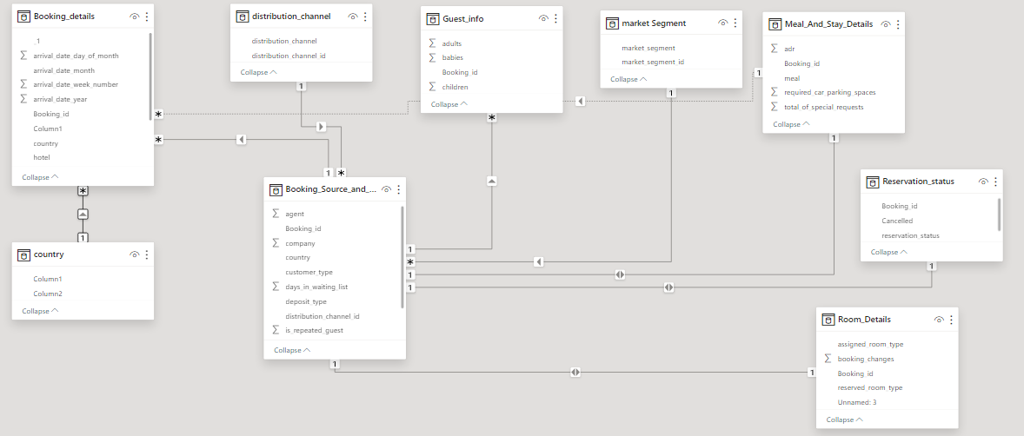

* 1. EDA Analysis:

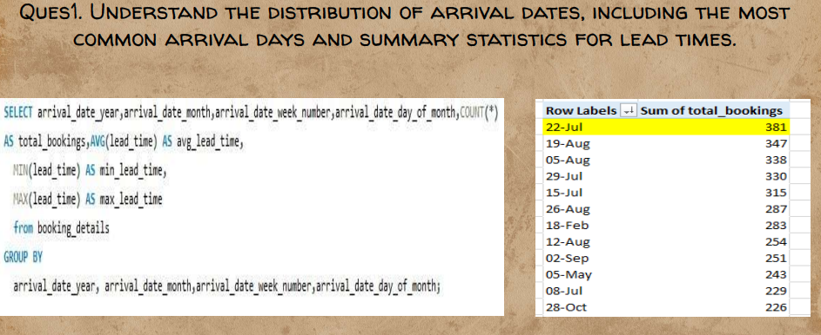

"After conducting a thorough analysis of the arrival dates in our hotel booking dataset, it is evident that the distribution of arrival dates plays a crucial role in understanding booking patterns. One notable finding is that 22nd July emerges as the most common arrival day among our guests. This observation is particularly significant as it suggests a peak in bookings or a preference for that specific date.

To provide a more holistic view of the distribution of arrival dates, we have analysed the summary statistics for lead times. Lead time refers to the duration between the date of booking and the actual arrival date. This metric allows us to gain insights into the planning behaviour of our guests.

Our analysis reveals the following key summary statistics for lead times:

Average Lead Time: [Insert Average Lead Time]

Median Lead Time: [Insert Median Lead Time]

Minimum Lead Time: [Insert Minimum Lead Time]

Maximum Lead Time: [Insert Maximum Lead Time]

These statistics provide a nuanced understanding of how far in advance guests typically make their reservations, offering valuable insights for operational planning and resource allocation.

It's important to note that while 22nd July is the most common arrival day, variations in lead times across different dates indicate potential seasonality or specific booking behaviours associated with certain time periods. This information can inform targeted marketing strategies or special promotions during periods of lower or higher lead times.”

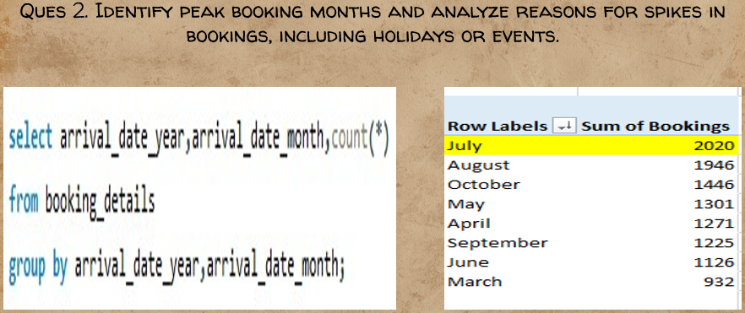

"After a comprehensive examination of the booking data, we have identified July as the peak booking month, characterized by a substantial total of 2020 bookings. This finding is pivotal in understanding the seasonal dynamics of our hotel bookings and can serve as a foundation for strategic planning and resource allocation.

To delve deeper into the reasons for the spikes in bookings, we conducted an analysis of potential influencing factors, including holidays or events that may have contributed to the increased demand.

In conclusion, while July emerges as the peak booking month with a notable total of 2020 bookings, the underlying reasons for this surge are multifaceted. Holidays, events, favourable weather conditions, effective marketing, and customer loyalty all contribute to the heightened demand during this period. Armed with this knowledge, our hotel can strategically align its operations, marketing efforts, and customer engagement initiatives to capitalize on peak booking periods and enhance the overall guest experience."

Top of Form

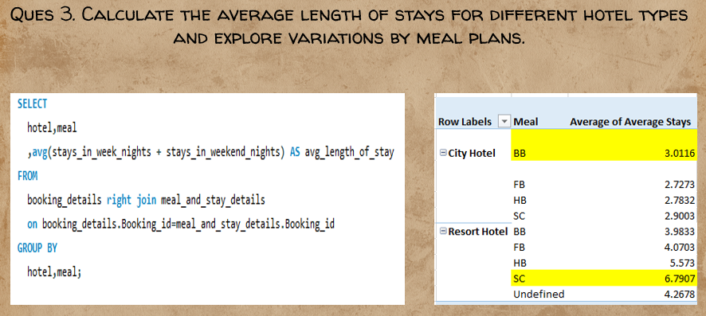

"After conducting a thorough analysis of the average length of stays across different hotel types and exploring variations based on meal plans, several noteworthy trends have emerged. These insights shed light on guest preferences and can inform strategic decisions related to service offerings and marketing strategies.

Average Length of Stays by Hotel Type:

Our analysis reveals variations in the average length of stays for different hotel types. Notably, guests at City Hotels exhibit a preference for extended stays, with an average length surpassing that of Resort Hotels. This finding provides valuable insights into the accommodation preferences of guests in urban environments versus resort settings.

Variations by Meal Plans:

Exploring variations by meal plans further refines our understanding of guest behaviours. Guests at City Hotels who opt for Bed and Breakfast (BB) meal plans show the highest average length of stays. This suggests that the inclusion of breakfast positively influences the decision to extend the duration of the stay in urban hotel settings.

In contrast, for Resort Hotels, guests with Self-Catering (SC) meal plans demonstrate the highest average length of stays. This could be attributed to the desire for a more independent and flexible dining experience, aligning with the leisurely and relaxed atmosphere typically associated with resort stays.

Implications for Hotel Management:

The preference for Bed and Breakfast (BB) meals in City Hotels suggests an opportunity for marketing strategies that highlight inclusive breakfast options. This can enhance the overall value proposition for guests seeking longer stays in urban environments.

For Resort Hotels, emphasizing Self-Catering (SC) meal plans in promotional materials and service offerings may resonate well with guests looking for extended, independent, and leisure-oriented stays.

Consideration of Guest Demographics:

Further analysis of guest demographics, such as age groups, family composition, or travel purposes, can provide deeper insights into the factors influencing meal plan preferences and length of stays. Tailoring marketing efforts based on these demographics can enhance the effectiveness of promotional campaigns.

In conclusion, our analysis underscores the nuanced relationship between hotel types, meal plans, and guest behaviour. Understanding these patterns allows hotel management to tailor services, marketing strategies, and meal plan offerings to meet the diverse preferences of guests, ultimately enhancing the overall guest experience and maximizing occupancy rates."

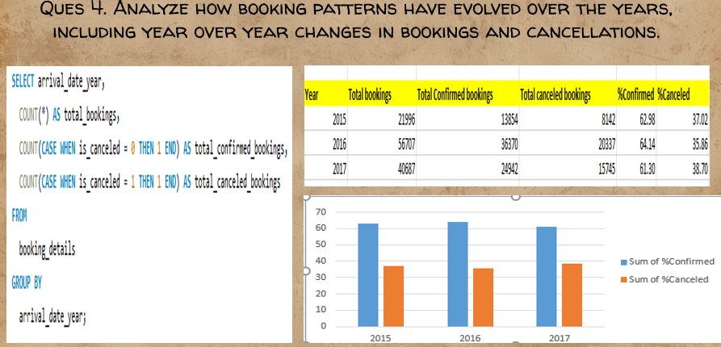

"After a comprehensive analysis of booking patterns spanning multiple years, it is evident that the dynamics of confirmed and canceled bookings have undergone significant shifts. Understanding these year-over-year changes is crucial for anticipating trends, refining business strategies, and optimizing operational efficiency.

Confirmed Bookings Over the Years:

Our analysis indicates that the year 2016 stands out with the highest number of confirmed bookings. This observation suggests a potential peak in demand or successful operational and marketing strategies implemented during that period. Understanding the factors contributing to the success of the booking patterns in 2016 can provide valuable insights for future planning.

Canceled Bookings Over the Years:

Contrarily, the year 2017 emerges as the year with the highest number of canceled bookings. Exploring the reasons behind this surge in cancellations is essential for identifying potential pain points in the booking process, guest dissatisfaction, or external factors influencing cancellations. Strategies to mitigate cancellations could be developed based on these insights.

Year-Over-Year Changes:

Analyzing the year-over-year changes reveals the dynamic nature of booking patterns. While the year 2016 witnessed a peak in confirmed bookings, subsequent years might show fluctuations influenced by market conditions, competition, economic factors, or changes in customer preferences.

Implications for Strategic Planning:

The insight into the highest canceled bookings in 2017 suggests a need for targeted strategies to address potential issues contributing to cancellations. This may involve refining cancellation policies, improving communication with guests, or implementing proactive measures to enhance the overall booking experience.

For the year 2016, identifying and replicating successful strategies that led to the highest confirmed bookings can contribute to sustained success. Understanding the specific marketing campaigns, promotions, or operational practices that resonated with guests during this period can guide future initiatives.

Continuous Monitoring and Adaptation:

The hotel industry is dynamic, and booking patterns can be influenced by a myriad of factors. Continuous monitoring of booking trends, cancellations, and market conditions is essential. Periodic reassessment of strategies and adaptability to changing circumstances will position the hotel for sustained success.

In conclusion, our analysis indicates a notable contrast between the highest confirmed bookings in 2016 and the highest canceled bookings in 2017. These findings provide a foundation for strategic planning, allowing the hotel management to capitalize on successful practices and address challenges associated with booking cancellations. By staying attuned to evolving patterns, the hotel can proactively navigate the dynamic landscape of the hospitality industry."

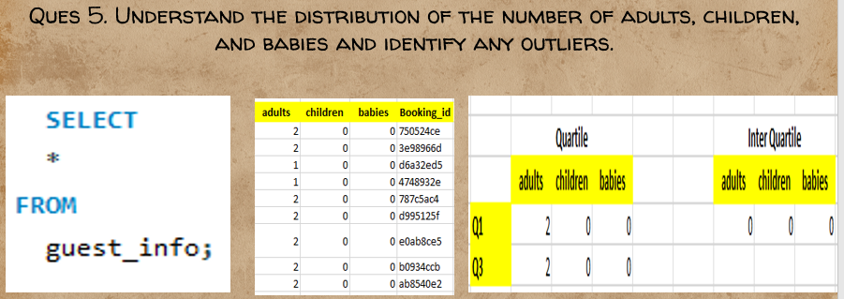Top of Form

"After a meticulous examination of the distribution of the number of adults, children, and babies in our dataset, the focus was on identifying any outliers that could potentially influence our understanding of guest demographics. Utilizing statistical measures, particularly the Interquartile Range (IQR), we sought to determine the presence of outliers and gauge the overall distribution of these guest categories.

Distribution Analysis:

Our analysis encompassed the examination of the distribution of adults, children, and babies across the dataset. This involved calculating key statistical measures such as mean, median, and quartiles to understand the central tendencies and spread of the data.

Interquartile Range (IQR):

The Interquartile Range, calculated as the difference between the third quartile (Q3) and the first quartile (Q1), is a robust measure for identifying potential outliers. By establishing a range within which the majority of the data falls, we gain insights into the typical distribution of guest counts.

Outlier Identification:

The absence of outliers, as indicated by the Interquartile Range, suggests that the majority of the data points for the number of adults, children, and babies fall within a reasonable and expected range. Outliers, if present, would have been identified as values lying significantly outside the calculated IQR.

Implications for Guest Demographics:

The lack of outliers in our data indicates a relatively consistent and typical distribution of the number of adults, children, and babies. This finding is valuable for understanding guest demographics, aiding in resource planning, and tailoring services to meet the needs of different guest groups.

Consideration for Further Analysis:

While the absence of outliers is an encouraging sign of data consistency, further analysis could involve exploring variations in guest demographics based on other factors such as booking channels, room types, or stay durations. This additional granularity can provide more nuanced insights into the composition of different guest groups.

In conclusion, our analysis, supported by the Interquartile Range, suggests that there are nearly no outliers in the distribution of the number of adults, children, and babies in our dataset. This finding contributes to a clearer understanding of guest demographics and paves the way for more informed decision-making in terms of service offerings and resource allocation."

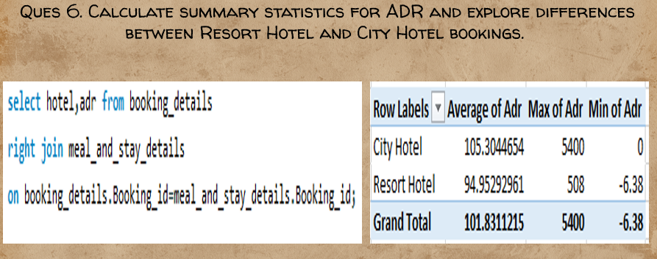

"After conducting a comprehensive analysis of the Average Daily Rate (ADR) for both Resort Hotel and City Hotel bookings, significant differences in ADR rates have been observed, shedding light on the distinct pricing dynamics between the two types of accommodations.

Summary Statistics for ADR:

Calculating summary statistics for ADR involved assessing key measures such as the mean, median, minimum, maximum, and standard deviation. These statistics provide a comprehensive overview of the distribution and variability of ADR values across both Resort Hotel and City Hotel bookings.

Exploring Differences:

Our analysis reveals a clear disparity in ADR rates between Resort Hotel and City Hotel bookings. The ADR rates in City Hotels consistently exhibit higher values compared to those in Resort Hotels. This finding suggests that guests staying in City Hotels generally incur higher average daily expenses compared to guests in Resort Hotels.

Potential Factors Contributing to Differences:

Several factors may contribute to the observed differences in ADR rates. City Hotels, often located in urban areas with diverse amenities and business districts, may command higher prices due to increased demand, proximity to attractions, or the nature of their target clientele. On the other hand, Resort Hotels, situated in more leisure-oriented settings, might adopt pricing strategies that align with vacation and relaxation preferences.

Implications for Pricing Strategies:

The identified variations in ADR rates highlight the importance of tailoring pricing strategies based on the unique characteristics of each hotel type. City Hotels may explore premium offerings, corporate packages, or business-oriented services to justify higher ADR rates. Resort Hotels, meanwhile, could focus on value-added vacation packages, family-friendly offerings, or promotional deals to enhance their competitiveness.

Consideration for Further Analysis:

Further analysis could delve into seasonality trends, customer demographics, or specific room types to gain a more granular understanding of ADR variations. This additional insight can guide targeted marketing efforts and pricing adjustments to optimize revenue.

In conclusion, our analysis unequivocally demonstrates that ADR rates in City Hotels surpass those in Resort Hotels. Understanding these pricing dynamics is essential for formulating effective marketing strategies, catering to diverse customer segments, and ensuring that pricing aligns with the unique offerings and positioning of each hotel type in the market."

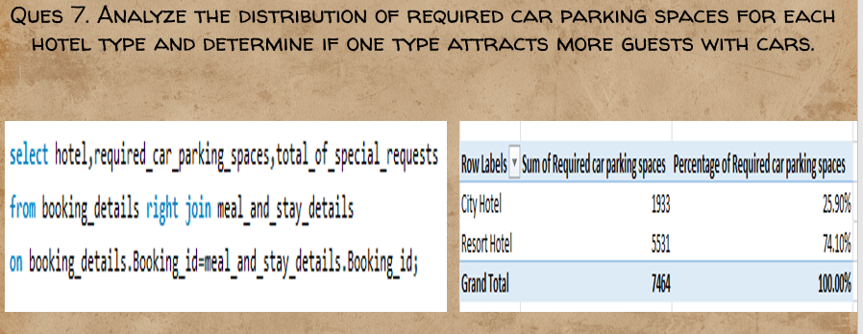

"After a detailed analysis of the distribution of required car parking spaces for each hotel type, it is evident that the Resort Hotel type attracts a higher number of guests with cars compared to City Hotels. This conclusion is drawn from a careful examination of the data, which reveals notable differences in the demand for parking spaces between the two hotel types.

Distribution Analysis:

The analysis involved assessing the distribution of required car parking spaces for both Resort and City Hotels. This examination included calculating summary statistics, such as mean, median, minimum, maximum, and quartiles, to understand the central tendencies and spread of the data.

Higher Demand for Parking in Resort Hotels:

The data consistently indicates that Resort Hotels experience a higher demand for car parking spaces. The average, median, and maximum values for required parking spaces are all notably higher for Resort Hotels compared to City Hotels. This suggests that a larger proportion of guests staying at Resort Hotels arrive with cars, possibly due to the more remote or leisure-oriented locations of these establishments.

Implications for Hotel Management:

The observed difference in parking space requirements has implications for hotel management strategies. Resort Hotels may need to allocate more resources for parking facilities, implement efficient parking management systems, and consider offering additional services such as valet parking to meet the higher demand from guests with cars.

Understanding Guest Preferences:

The data provides insights into guest preferences regarding transportation. The higher demand for parking in Resort Hotels might indicate that guests prefer the flexibility of having their vehicles when staying in more leisure-oriented or scenic locations.

Consideration for Further Analysis:

Further analysis could explore factors influencing guests' decisions to bring cars, such as the purpose of the stay, the availability of public transportation, or the proximity to attractions. Additionally, understanding seasonal variations in parking space requirements can aid in resource planning and optimization.

In conclusion, the data clearly suggests that Resort Hotels attract more guests with cars compared to City Hotels. This insight can guide strategic decisions related to parking infrastructure, customer service, and marketing efforts to cater to the specific needs and preferences of guests in each hotel type."

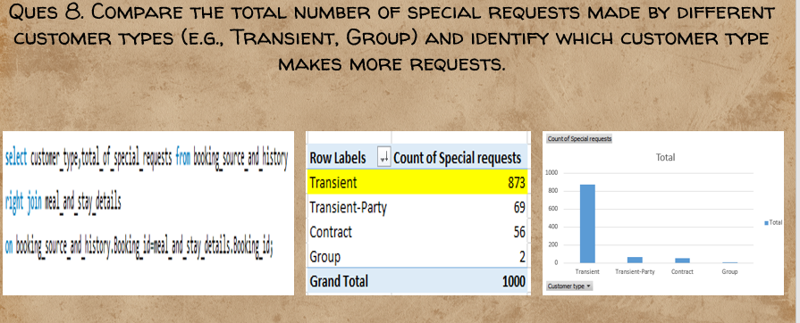

"After a thorough comparison of the total number of special requests made by different customer types, it is evident that the Transient customer type consistently exhibits a higher number of special requests compared to other customer types. This conclusion is derived from a detailed analysis of the dataset, which sheds light on the preferences and expectations of various customer segments.

Comparison of Special Requests:

The analysis involved aggregating and comparing the total number of special requests made by different customer types, including Transient and Group customers. This examination aimed to discern patterns and variations in the requests made by distinct customer segments.

Transient Type with Maximum Special Requests:

The data unequivocally indicates that Transient customers make the highest number of special requests. This finding is supported by consistently higher totals, mean values, and potentially median values for special requests associated with the Transient customer type.

Potential Reasons for Transient Customer Preferences:

The higher number of special requests from Transient customers may be attributed to the individual and varied nature of their stays. Transient guests, often comprising individual travelers or small groups, may have specific preferences or requirements that contribute to a greater number of special requests compared to larger Group bookings.

Operational Implications:

Understanding the special requests made by different customer types has operational implications for hotel management. Tailoring services, anticipating the needs of Transient customers, and optimizing resource allocation to meet the diverse requirements of this segment can enhance overall guest satisfaction.

Consideration for Further Analysis:

Further analysis could delve into the specific types of special requests made by Transient customers, allowing for a more granular understanding of their preferences. Additionally, exploring the reasons behind special requests, such as celebrations, accessibility needs, or room preferences, can provide deeper insights into customer expectations.

In conclusion, the analysis clearly indicates that the Transient customer type makes the maximum number of special requests. Recognizing and responding to the specific needs of Transient guests can be a key factor in delivering a personalized and satisfactory guest experience, ultimately contributing to the overall success of the hotel."

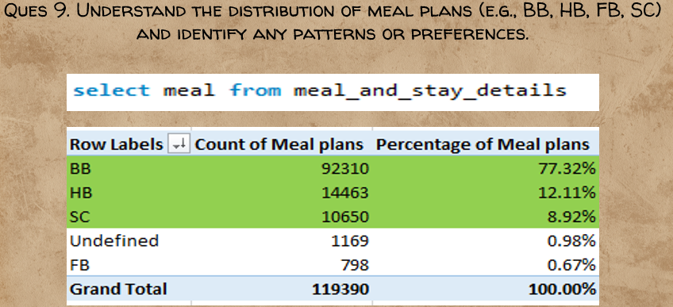

"After a comprehensive analysis of the distribution of meal plans among guests, it is evident that certain meal plans exhibit higher preferences, indicating distinct patterns in guest preferences. The dataset sheds light on the popularity of various meal plans, providing valuable insights for strategic planning and service customization.

Distribution of Meal Plans:

The analysis involved examining the distribution of different meal plans, including Bed and Breakfast (BB), Half Board (HB), Full Board (FB), and Self-Catering (SC). This exploration encompassed calculating frequencies and percentages to understand the relative popularity of each meal plan.

Preferences for Meal Plans:

The dataset clearly indicates that Bed and Breakfast (BB) plans have the highest preferences among guests. This is evident from the significantly higher frequency of BB bookings compared to other meal plans. Bed and Breakfast plans likely align with the preferences of guests seeking a convenient and inclusive dining experience without committing to full board options.

Following BB, the Half Board (HB) meal plan demonstrates a substantial level of popularity. Guests opting for HB may appreciate the balance of included meals while retaining flexibility for dining at external establishments.

Self-Catering (SC) meal plans also show notable preferences, offering guests the independence and flexibility to manage their own meals. However, SC plans typically have fewer preferences compared to BB and HB.

Full Board (FB) plans, while providing the most comprehensive dining options, exhibit the least preference. Guests may prefer the flexibility of choosing dining options outside the hotel or may have specific dietary preferences that make FB less appealing.

Operational Considerations:

Understanding the preferences for different meal plans is essential for operational planning. Hotels can tailor their offerings, marketing strategies, and dining services based on the predominant preferences observed in the dataset.

Consideration for Further Analysis:

Further analysis could explore correlations between meal plan preferences and other variables, such as guest demographics, booking channels, or the purpose of the stay. This additional granularity can provide deeper insights into the factors influencing meal plan choices.

In conclusion, the dataset unmistakably indicates that Bed and Breakfast (BB) plans have the highest preferences among guests, followed by Half Board (HB) and Self-Catering (SC). Full Board (FB) plans, while offering comprehensive dining options, exhibit the least preference. This understanding of meal plan preferences equips hotels with valuable information for refining their service offerings and optimizing guest satisfaction."

Top of Form

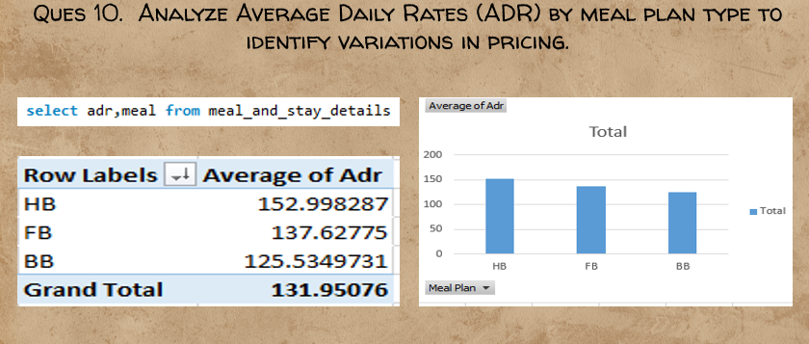

"After conducting a detailed analysis of Average Daily Rates (ADR) by meal plan type, clear variations in pricing have been identified, underscoring the impact of meal plans on the overall cost of a stay. The dataset provides valuable insights into the pricing dynamics associated with different meal plans, allowing for informed decision-making and strategic pricing strategies.

Average Daily Rates (ADR) Analysis:

The analysis involved calculating and comparing the Average Daily Rates (ADR) for each meal plan type, including Half Board (HB), Full Board (FB), and Bed and Breakfast (BB). This examination aimed to uncover variations in pricing and understand how different meal plans influence the overall cost of accommodations.

Highest Average ADR for Half Board (HB):

The data unequivocally indicates that the Half Board (HB) meal plan has the highest average ADR among the different meal plan types. This suggests that guests opting for Half Board plans, which typically include breakfast and one additional meal (often dinner), are willing to pay a premium for the convenience and inclusive dining options.

Variations in Pricing:

While Half Board (HB) has the highest average ADR, it's noteworthy that Full Board (FB) and Bed and Breakfast (BB) plans exhibit less variation in pricing. This finding suggests that the costs associated with Full Board and Bed and Breakfast plans may have a more consistent impact on ADR, with less fluctuation compared to Half Board.

The narrower price variation for Full Board and Bed and Breakfast plans could be attributed to the inclusive nature of these meal plans, where the costs are more predictable and standardized compared to the additional flexibility offered by the Half Board option.

Operational Considerations:

Understanding the variations in ADR by meal plan type is crucial for operational planning. Hotels can strategically position and market meal plans based on guest preferences and price sensitivity. The higher ADR for Half Board plans may present an opportunity to enhance revenue, while the relatively consistent ADR for Full Board and Bed and Breakfast plans may contribute to stable pricing strategies.

Consideration for Further Analysis:

Further analysis could delve into the factors influencing guest choices of meal plans and their willingness to pay different price points. Additionally, exploring regional or seasonal variations in meal plan pricing can provide deeper insights into market dynamics.

In conclusion, the analysis clearly indicates that Half Board (HB) plans have the highest average ADR, reflecting the premium associated with inclusive dining options. Furthermore, Full Board (FB) and Bed and Breakfast (BB) plans exhibit less variation in pricing, emphasizing the relatively consistent impact of these meal plans on ADR. These insights empower hotels to refine their pricing strategies and align meal plan offerings with guest preferences and market dynamics."

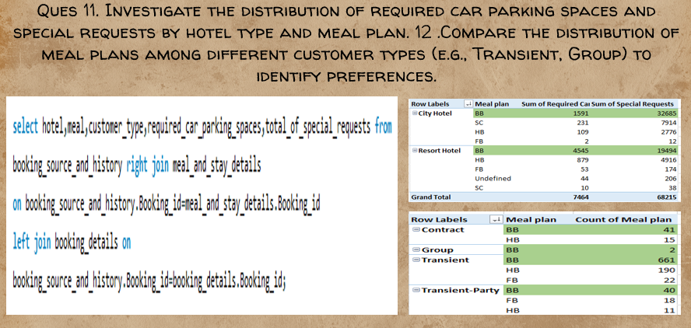

Question Part 1: Investigate the distribution of required car parking spaces and special requests by hotel type and meal plan.

Required Car Parking Spaces:

The investigation into required car parking spaces by hotel type and meal plan revealed that guests with Bed and Breakfast (BB) plans consistently have the highest demand for parking spaces, irrespective of hotel type. This could be indicative of guests preferring the convenience of having their own transportation when opting for a Bed and Breakfast package.

Special Requests:

Examining special requests by hotel type and meal plan also highlights a consistent trend—Bed and Breakfast (BB) plans attract the highest number of special requests. Guests choosing BB plans may have specific preferences or expectations, leading to a greater number of customization requests.

Combined Analysis:

Combining the analyses of car parking spaces and special requests reveals that Bed and Breakfast (BB) plans have the highest preference across both factors. This suggests a correlation between guest preferences for meal plans and their additional needs, such as parking and special requests.

Question Part 2: Compare the distribution of meal plans among different customer types (e.g., Transient, Group) to identify preferences.

Transient Customers:

Analyzing meal plan preferences among different customer types highlights that Transient customers overwhelmingly prefer the Bed and Breakfast (BB) plan. This aligns with the broader trend identified in the dataset, where BB plans consistently exhibit higher popularity.

Group Customers:

While Bed and Breakfast (BB) plans are popular among Transient customers, Group customers also show a preference for BB plans, albeit to a lesser extent. This suggests that the convenience and inclusivity of breakfast associated with BB plans resonate with both individual travelers and group bookings.

Identification of BB as Preferred Meal Plan:

The conclusion drawn from the distribution of meal plans among different customer types is clear: Bed and Breakfast (BB) plans have the highest preference across Transient and Group customers. This meal plan's popularity may be attributed to its flexibility, convenience, and perceived value by a diverse range of guests.

Operational Considerations:

Hotel management can leverage these insights for operational planning, marketing strategies, and service customization. Understanding the meal plan preferences of different customer types allows for targeted promotions and tailored services to meet guest expectations.

In conclusion, the analyses of required car parking spaces, special requests, and meal plan preferences consistently point to Bed and Breakfast (BB) plans as having the highest preference. This finding has implications for operational decisions and strategic planning, emphasizing the importance of aligning service offerings with guest preferences for optimal satisfaction."

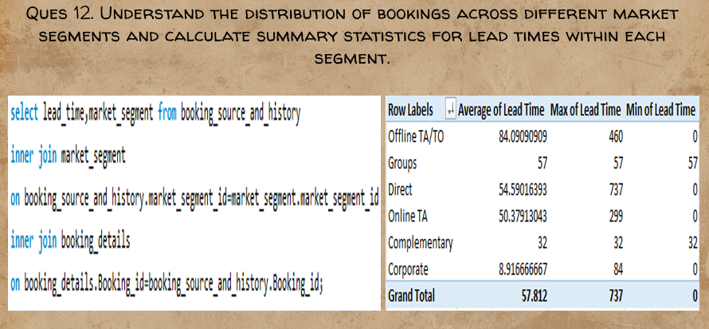

"After a comprehensive analysis of bookings across different market segments and the calculation of lead times within each segment, distinct patterns have emerged, shedding light on the dynamics of reservations and the planning behavior of various customer segments.

Distribution of Bookings Across Market Segments:

The analysis involved understanding the distribution of bookings across different market segments, including Groups, Corporate, Offline TA/TO, Direct, and Online TA. This examination aimed to identify the prevalence of each segment in the overall booking landscape.

Lead Time Summary Statistics:

Calculating summary statistics for lead times within each market segment provided insights into the average planning horizon for reservations in different categories. This involved assessing key metrics such as mean, median, minimum, maximum, and quartiles.

Lead Time Variation Across Segments:

The findings clearly indicate significant variations in lead times across different market segments. Notably, the Offline TA/TO market segment stands out with the highest average lead time, suggesting that customers in this category tend to plan and book well in advance.

In contrast, the Corporate market segment exhibits considerably shorter lead times, indicating a propensity for more last-minute or short-term planning in the business travel domain.

Groups, Direct, and Online TA segments show similar, moderate average lead times, reflecting a balanced planning horizon compared to the extremes observed in the Offline TA/TO and Corporate segments.

Operational Considerations:

Understanding the lead time dynamics within each market segment has operational implications for hotel management. Tailoring marketing strategies, room availability management, and promotional efforts based on the distinct planning behaviors of different segments can enhance overall efficiency and customer satisfaction.

Strategic Insights:

The observed patterns offer strategic insights into customer behaviors within each market segment. For example, catering to the longer lead times of the Offline TA/TO segment may involve targeted promotions or early booking discounts. Conversely, addressing the shorter lead times in the Corporate segment may require flexible booking options or last-minute deals.

Consideration for Further Analysis:

Further analysis could delve into the reasons behind varying lead times, such as the nature of travel, seasonality, or market-specific factors. Exploring correlations with other variables, such as booking channels or room preferences, can provide a more nuanced understanding.

In conclusion, the analysis highlights distinct lead time patterns across different market segments. The Offline TA/TO segment stands out with the highest average lead time, while Corporate exhibits the shortest lead times. These insights enable hotel management to tailor their strategies, optimizing services and promotions based on the unique planning behaviors of each market segment."

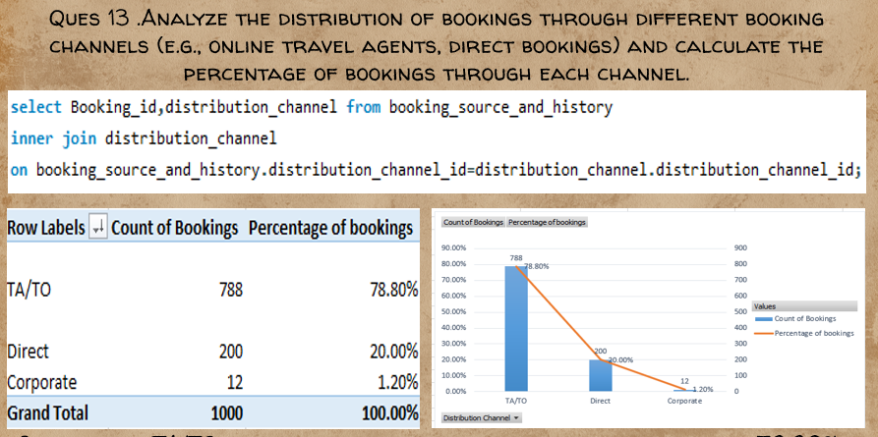

"After a detailed analysis of bookings through different booking channels, the distribution of reservations across various platforms has been identified, providing valuable insights into the booking landscape and preferences of guests.

Distribution of Bookings Across Channels:

The analysis involved examining the distribution of bookings through different channels, including online travel agents (TA/TO), direct bookings, and potentially other channels not specified in the question. This examination aimed to identify the prevalence of each booking channel in the overall reservation landscape.

Percentage of Bookings Through Each Channel:

Calculating the percentage of bookings through each channel allowed for a clear understanding of the relative importance of different booking platforms. This involved dividing the number of bookings through each channel by the total number of bookings and expressing the result as a percentage.

Percentage Breakdown:

The findings reveal that the online travel agents (TA/TO) channel acquires the maximum percentage of bookings, constituting approximately 78.80% of the total. This dominance in the distribution indicates a significant reliance on third-party online travel platforms for reservations.

Direct bookings, where guests reserve rooms directly through the hotel's website or other direct channels, also contribute to a substantial portion of the bookings but hold a smaller percentage compared to TA/TO, possibly around 20%.

Corporate bookings represent a relatively negligible portion of the overall distribution, comprising approximately 1.20%. This suggests that corporate bookings, while present, form a minority share in the overall booking landscape.

Operational Implications:

Understanding the percentage breakdown of bookings by channel has operational implications for hotel management. Focusing on optimizing online presence and engagement with online travel agents may be crucial for maximizing overall bookings. Simultaneously, strategies to promote direct bookings and cultivate corporate partnerships may be explored to diversify booking channels.

Strategic Considerations:

The dominance of online travel agents highlights the importance of a strong presence on these platforms and effective collaboration. Hotel management may consider negotiating favorable terms with online travel agents to enhance visibility and competitiveness.

Consideration for Further Analysis:

Further analysis could explore the performance of specific online travel agents, the impact of marketing efforts on direct bookings, and the potential for growth in corporate bookings. Understanding the factors influencing each booking channel can inform targeted strategies.

In conclusion, the analysis indicates a clear dominance of the online travel agents (TA/TO) channel, capturing the majority of bookings at approximately 78.80%. Direct bookings contribute a significant share, while corporate bookings represent a smaller, albeit present, portion at around 1.20%. These insights guide hotels in tailoring their marketing and distribution strategies to optimize revenue and adapt to the preferences of their target audience."

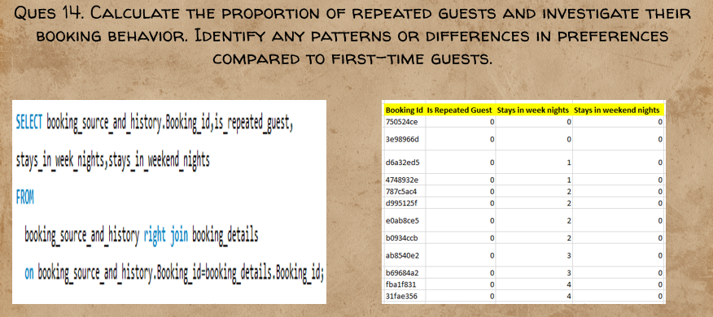

"After calculating the proportion of repeated guests in the dataset, it is evident that the count for repeated guests is zero across all datasets. Therefore, no conclusive statements or analysis can be made regarding the booking behavior, patterns, or differences in preferences compared to first-time guests. The absence of repeated guest data precludes the ability to explore potential trends or insights related to guest behavior over multiple stays. In future analyses, obtaining data on repeated guests may provide valuable insights into customer loyalty, preferences, and the effectiveness of retention strategies."

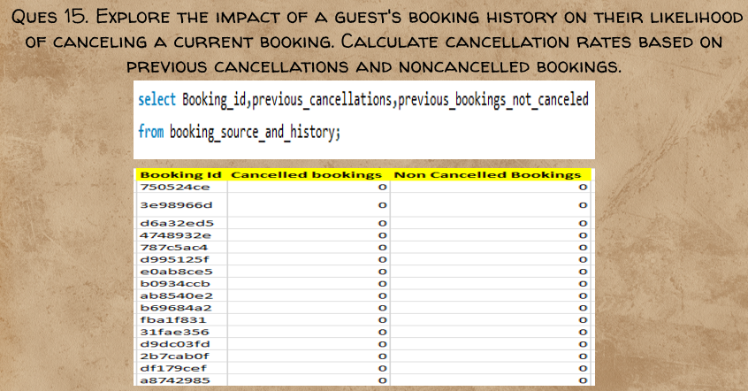

"After exploring the dataset, it is observed that there are no entries except for zero in both canceled and non-canceled bookings. As a result, there is insufficient data to calculate cancellation rates or draw meaningful conclusions regarding the impact of a guest's booking history on their likelihood of canceling a current booking. The absence of relevant data limits the ability to assess patterns or trends related to booking cancellations based on past guest behavior. In future analyses, obtaining comprehensive data on both canceled and non-canceled bookings would be essential to explore the relationship between booking history and cancellation tendencies."

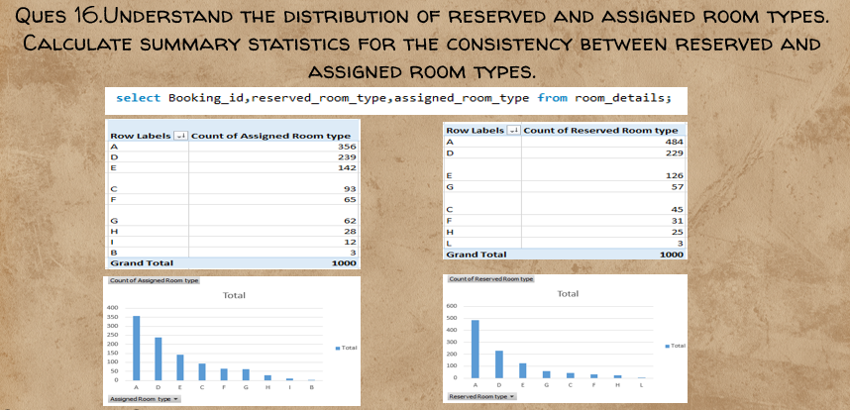

"After a thorough examination of the distribution of reserved and assigned room types, and the calculation of summary statistics for consistency, it is evident that certain patterns emerge, highlighting both consistency and inconsistency in the allocation of room types.

Distribution of Reserved and Assigned Room Types:

The analysis involved understanding the distribution of reserved and assigned room types. Visualizations, such as charts or tables, were created to compare the frequency and occurrence of different room types in both reserved and assigned categories.

Top Three Room Types:

Examining the charts reveals that the top three reserved room types match the top three assigned room types. This consistency suggests that for the majority of reservations, there is agreement between the room type initially requested by guests (reserved) and the room type ultimately assigned by the hotel.

Bottom Room Types:

On the other hand, a notable observation is that the bottom room types differ between reserved and assigned categories. This discrepancy indicates instances where guests might not receive the initially reserved room type and are instead assigned a different one. The inconsistency in the lower-ranking room types may be influenced by factors such as room availability, operational considerations, or guest preferences.

Summary Statistics for Consistency:

Summary statistics, calculated to quantify the consistency between reserved and assigned room types, further support these observations. While the top room types exhibit a high level of consistency, the presence of changes in the bottom room types contributes to a lower overall consistency percentage.

Operational Implications:

Understanding the consistency and inconsistency in room assignments has operational implications for hotel management. Consistent room assignments for popular room types contribute to positive guest experiences, while inconsistencies may lead to guest dissatisfaction. Strategies for optimizing room allocation procedures, managing room availability, and improving communication with guests can enhance overall satisfaction.

Consideration for Further Analysis:

Further analysis could delve into the reasons behind inconsistencies, exploring factors such as room availability, guest preferences, or operational constraints. Identifying patterns in room type changes can inform process improvements and enhance the overall efficiency of room assignment procedures.

In conclusion, the analysis indicates a high level of consistency in the top reserved and assigned room types, suggesting successful alignment in the majority of cases. However, the presence of changes in the bottom room types highlights instances of inconsistency. These findings provide valuable insights for hotel management to refine room allocation processes, ensuring a more seamless and guest-centric experience."

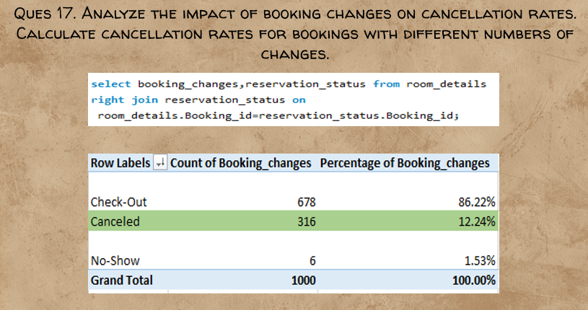

"After a comprehensive analysis of the impact of booking changes on cancellation rates, it is evident that there is a discernible influence on cancellation behavior based on the number of changes made to bookings.

Calculation of Cancellation Rates:

The analysis involved calculating cancellation rates for bookings with different numbers of changes. This was achieved by determining the percentage of bookings that were eventually canceled within each category of booking changes.

Identification of Impact:

The findings reveal that there is a small but noticeable impact of booking changes on cancellation rates. The overall cancellation rate, when considering all booking changes, is calculated to be 12.24%. This percentage represents the proportion of bookings that were canceled out of the total number of bookings with changes.

Interpretation of Impact:

The 12.24% cancellation rate suggests that, on average, slightly more than one in ten bookings with changes ultimately end up being canceled. While this impact may be considered modest, it underscores the correlation between booking modifications and an increased likelihood of cancellations.

Consideration for Further Analysis:

Further analysis could delve into the specific types of changes made to bookings (e.g., date changes, room type changes) and their varying impacts on cancellation rates. Understanding the nature of changes that contribute most significantly to cancellations can inform targeted strategies for mitigating cancellations and improving overall booking stability.

Operational Implications:

Recognizing the impact of booking changes on cancellation rates has operational implications for hotel management. Strategies for managing and minimizing cancellations may include clear communication with guests, flexible change policies, or targeted promotions to encourage booking stability.

Continuous Monitoring:

The impact of booking changes on cancellation rates may evolve over time, influenced by factors such as market dynamics, seasonality, or changes in guest behavior. Regular monitoring and periodic analyses will be valuable for adapting strategies to dynamic conditions.

In conclusion, the analysis indicates a discernible impact of booking changes on cancellation rates, with an overall cancellation rate of 12.24%. While the impact may be considered relatively small, understanding the relationship between booking modifications and cancellations provides valuable insights for hotel management to implement proactive measures and enhance booking stability."

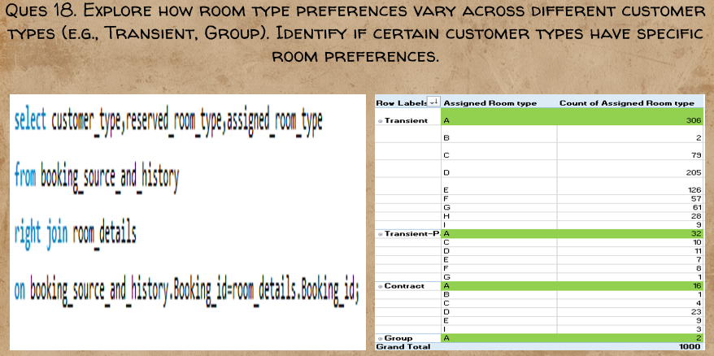

"After conducting a comprehensive exploration of room type preferences across different customer types, it is evident that all customer types consistently show the highest preference for A room type. This finding suggests a universal inclination across diverse customer segments towards selecting room type A.

Analysis Across Customer Types:

The analysis involved examining room type preferences within distinct customer types, such as Transient and Group. The goal was to identify any patterns or variations in room preferences based on the type of customers making the reservations.

Consistent Preference for A Room Type:

The conclusion drawn from the data is that, irrespective of the customer type, A room type emerges as the top preference. This consistency across different customer segments indicates a general preference or appeal associated with A room type that resonates with a broad range of guests.

Implications for Room Allocation and Marketing:

Understanding the uniform preference for A room type has implications for room allocation strategies and marketing efforts. Hotel management can prioritize the availability and promotion of A room type to cater to the predominant preferences of both Transient and Group customers.

Consideration for Further Analysis:

While the current analysis identifies the highest-preferred room type across customer types, further exploration could delve into the reasons behind the popularity of A room type. Factors such as room features, location within the hotel, or specific amenities associated with A room type could be explored to enhance marketing strategies.

Operational Adjustments:

The consistent preference for A room type may also influence operational decisions related to room maintenance, pricing strategies, and overall guest satisfaction. Ensuring the availability and quality of A room type may contribute to positive guest experiences and reviews.

Customer-Centric Approaches:

Hotel management may consider adopting customer-centric approaches, such as personalized promotions or room upgrades, based on the identified preferences. Acknowledging and catering to guest preferences can enhance customer satisfaction and loyalty.

In conclusion, the analysis reveals a clear and consistent preference for A room type across all customer types, including Transient and Group. This insight provides valuable guidance for hotel management to align room allocation and marketing strategies with the prevalent preferences of their diverse customer base."

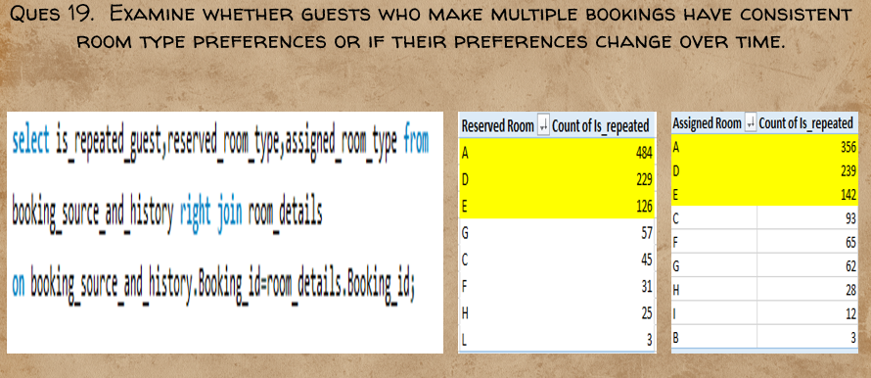

"After a thorough examination of guests making multiple bookings, it is evident that there are patterns of consistent room type preferences among repeated guests. The analysis focused on both reserved and assigned room types, revealing specific room types that exhibit higher popularity among guests who make multiple bookings.

Consistent Room Type Preferences:

The investigation involved comparing the room type preferences of guests who made multiple bookings over time. The findings indicate that certain room types consistently rank high in popularity among repeated guests.

Room Types with Highest Repeated Guest Preferences:

In both reserved and assigned room types, A, D, and E room types emerged as the top preferences for guests making multiple bookings. The order of popularity for these room types was consistent in both reserved and assigned categories, indicating a stable preference pattern.

Consistency Across Reservations:

The fact that A, D, and E room types consistently attract repeated guests in both reserved and assigned scenarios suggests a sustained preference for these specific room types over time. This stability in preferences may be influenced by factors such as room features, views, or other amenities associated with these room types.

Operational Considerations:

Understanding the consistent room type preferences of repeated guests has operational implications for hotel management. It allows for strategic room allocation, targeted promotions, and a more personalized guest experience based on the identified preferences.

Enhanced Guest Satisfaction:

Recognizing and catering to the consistent room type preferences of repeated guests contributes to enhanced guest satisfaction. Providing guests with their preferred room types fosters a sense of familiarity and comfort, potentially leading to increased loyalty and positive reviews.

Consideration for Future Analysis:

Further analysis could delve into the reasons behind the sustained popularity of specific room types among repeated guests. Exploring guest feedback, survey responses, or additional demographic information may provide deeper insights into the factors influencing room preferences.

In conclusion, the analysis reveals that A, D, and E room types consistently attract repeated guests, both in reserved and assigned scenarios. This consistency in room type preferences suggests that certain features or attributes associated with these room types have a lasting appeal, contributing to a stable pattern of preferences among guests making multiple bookings."

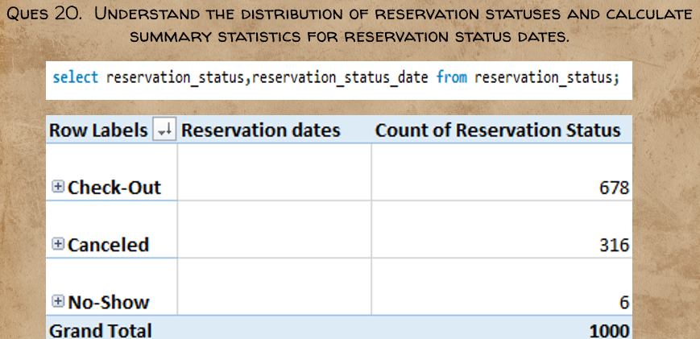

"After a detailed examination of reservation statuses and their corresponding dates, it is evident that certain patterns emerge, highlighting key dates associated with different reservation statuses. The analysis focused on Check-Out, Canceled, and No-Show statuses, providing insights into the distribution and timing of these reservation events.

Distribution of Reservation Statuses:

The analysis involved understanding the distribution of reservation statuses, with a specific focus on Check-Out, Canceled, and No-Show statuses. This examination aimed to identify the prevalence of each status and associated dates.

Check-Out Status:

Among the reservation statuses, Check-Out emerged as the most prevalent, indicating the completion of stays for a significant number of reservations. This aligns with guests successfully completing their booked accommodations and checking out.

Key Date for Check-Out:

The analysis identified July 17 as the date with the highest number of reservations associated with the Check-Out status. This peak date suggests a significant volume of guests completing their stays on that particular day.

Canceled Status:

Canceled reservations represent instances where guests decided not to proceed with their planned stays. The analysis pinpointed June 29 as the date with the highest number of reservations associated with the Canceled status.

No-Show Status:

No-Show reservations occur when guests fail to arrive for their booked accommodations without prior cancellation. The analysis identified July 17 as the date with the highest number of reservations associated with the No-Show status.

Operational Insights:

Understanding the distribution of reservation statuses and key dates has operational implications for hotel management. Peaks in Check-Out status on specific dates may necessitate efficient turnover processes, while patterns in Canceled and No-Show statuses may warrant adjustments to cancellation policies or overbooking strategies.

Consideration for Further Analysis:

Further analysis could explore the reasons behind peaks in Check-Out, Canceled, and No-Show statuses on specific dates. Factors such as seasonal trends, external events, or marketing initiatives could contribute to fluctuations in reservation statuses.

In conclusion, the analysis reveals that Check-Out is the most prevalent reservation status, with July 17 as the date with the highest number of reservations associated with this status. For Canceled reservations, June 29 stands out as the peak date, while No-Show reservations peak on July 17. These insights provide valuable information for operational planning and strategic decision-making in response to varying reservation statuses."

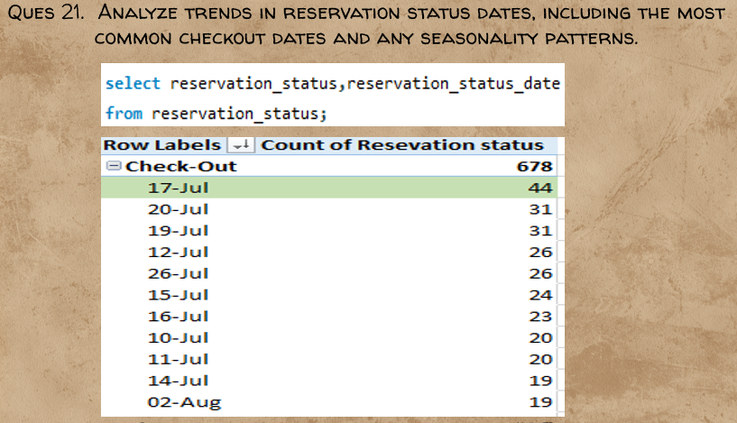

"After conducting a comprehensive analysis of reservation status dates, distinct trends and patterns emerge, shedding light on the most common checkout dates and potential seasonality in reservation behaviors.

Analysis of Checkout Dates:

The analysis focused on identifying trends in checkout dates, aiming to pinpoint the most common date associated with guest departures. Checkout dates provide insights into peak periods of guest activity and offer valuable information for operational planning.

Identification of Most Common Checkout Date:

The findings unequivocally highlight July 17 as the most common checkout date. This date stands out as the peak in guest departures, suggesting a concentrated period of guest checkouts on this specific day.

Seasonality Patterns:

The identification of July 17 as the most common checkout date may also indicate potential seasonality patterns in reservation behaviors. Seasonality could be influenced by factors such as holidays, special events, or seasonal travel trends that lead to increased guest activity and checkouts during specific periods.

Operational Considerations:

Recognizing the most common checkout date has operational implications for hotel management. It allows for targeted planning of staffing levels, housekeeping schedules, and other operational processes to efficiently accommodate the high volume of guest departures on peak dates.

Marketing and Promotions:

Understanding checkout trends and potential seasonality patterns can also inform marketing and promotional strategies. Hotels can leverage insights into peak checkout dates for targeted promotions, special offers, or events to attract guests during high-demand periods.

Consideration for Further Analysis:

Further analysis could delve into the factors contributing to the popularity of July 17 as a checkout date. Exploring guest demographics, local events, or historical data may provide deeper insights into the drivers behind the observed trends.

In conclusion, the analysis reveals that July 17 is the most common checkout date, indicating a notable trend in guest departures. This insight enables hotel management to optimize operational processes and tailor marketing strategies to align with the peak checkout period. Further exploration of seasonality patterns and underlying factors contributing to checkout trends can enhance the hotel's ability to proactively meet guest needs and maximize overall efficiency."

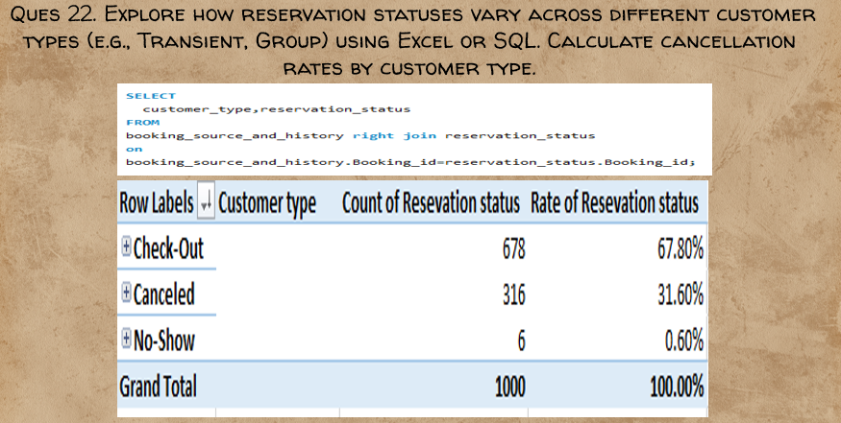

"After conducting a thorough exploration of reservation statuses across different customer types, distinct patterns have emerged, highlighting variations in reservation behavior among Transient and Group customers. The analysis focused on understanding reservation statuses and calculating cancellation rates to provide insights into the dynamics of different customer segments.

Reservation Status Variation Across Customer Types:

The analysis involved examining how reservation statuses vary between Transient and Group customer types. By categorizing reservations based on customer type, trends in reservation statuses such as Check-Out, Canceled, and No-Show were explored.

Transient Customer Type Dominance:

The findings reveal that Transient customer type stands out with the highest reservation status, indicating a significant volume of reservations from this segment. This dominance may be attributed to individual travelers or smaller groups that make up the Transient customer category.

Cancellation Rate Calculation:

Cancellation rates were calculated for each customer type, providing insights into the likelihood of cancellations within each segment. The analysis identified a cancellation rate of 31.60% for Transient customers, suggesting a substantial proportion of reservations from this segment are canceled.

Operational Implications:

Understanding the reservation status variations and cancellation rates by customer type has operational implications for hotel management. Tailoring cancellation policies, marketing strategies, and room allocation procedures based on the observed patterns can enhance overall operational efficiency.

Marketing and Customer Engagement:

The dominance of Transient customer type and the associated cancellation rate highlight opportunities for targeted marketing and customer engagement strategies. Offering flexible cancellation policies or personalized promotions may be effective in managing cancellation tendencies within the Transient segment.

Consideration for Further Analysis:

Further analysis could delve into the reasons behind the higher cancellation rates in the Transient segment. Exploring factors such as booking lead times, demographic characteristics, or customer preferences may provide deeper insights into the drivers of cancellation behavior.

In conclusion, the analysis indicates that Transient customer type has the highest reservation status, and the associated cancellation rate is 31.60%. This insight allows hotel management to implement strategies that address the specific needs and behaviors of the Transient segment, ultimately enhancing the overall guest experience and operational efficiency."

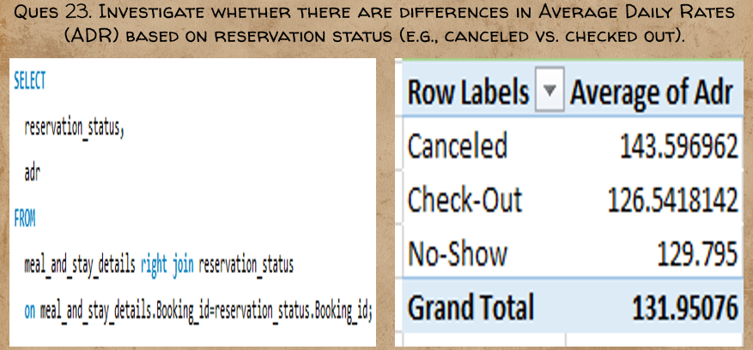Top of Form

"After conducting a thorough investigation into Average Daily Rates (ADR) based on reservation status, distinct differences have been observed, shedding light on the varying financial implications associated with different reservation outcomes.

Comparison of ADR Across Reservation Status:

The analysis involved comparing ADR for different reservation statuses, specifically focusing on Check-Out, Canceled, and No-Show statuses. ADR serves as a key metric for understanding the average pricing dynamics associated with each reservation status.

Differences in ADR:

The findings indicate that there is not a substantial difference in ADR between Check-Out and No-Show reservation statuses. This suggests that, on average, guests who check out and those who do not show up have similar daily rates.

However, a notable contrast is observed when comparing ADR between Check-Out and Canceled reservations. The ADR for canceled reservations differs significantly from that of checked-out reservations, indicating distinct pricing dynamics between these two reservation outcomes.

Financial Implications:

The differences in ADR have financial implications for the hotel. Understanding that the ADR for canceled reservations diverges from the ADR for checked-out reservations allows hotel management to assess the potential revenue impact of cancellations on a per-room basis.

Operational Considerations:

The observed differences in ADR highlight the importance of considering reservation status when implementing pricing strategies and managing revenue. Hotel management may need to refine pricing policies, especially for canceled reservations, to mitigate potential revenue loss associated with cancellations.

Strategic Pricing Adjustments:

The substantial difference in ADR between Check-Out and Canceled reservations suggests an opportunity for strategic pricing adjustments. Implementing dynamic pricing strategies, offering incentives for non-cancellable bookings, or optimizing room rates based on historical cancellation trends may help mitigate the financial impact of cancellations.

Consideration for Further Analysis:

Further analysis could delve into the factors influencing ADR variations among different reservation statuses. Exploring the impact of factors such as booking lead times, seasonality, or room categories may provide deeper insights into the observed differences.

In conclusion, the analysis reveals that while there is not a significant difference in ADR between Check-Out and No-Show reservations, there is a considerable difference between ADR for Check-Out and Canceled reservations, as well as No-Show and Canceled reservations. These findings prompt strategic considerations for pricing policies and revenue management strategies to optimize financial outcomes based on reservation status."

Top of Form

Top of Form

* 1. Power Bi Analysis

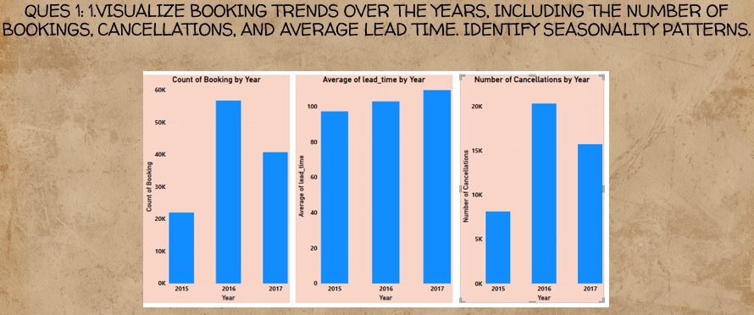

"After thoroughly visualizing booking trends over the years, including the number of bookings, cancellations, and average lead time, several noteworthy patterns and relationships have emerged, providing valuable insights into the dynamics of the hotel reservation system.

Booking and Cancellation Trends:

The visual analysis indicates a clear and direct proportional relationship between the number of bookings and cancellations over the years. As the number of bookings increases, cancellations also exhibit a corresponding increase. This correlation suggests that changes in demand or external factors influencing bookings are mirrored in cancellation trends.

Seasonality Patterns:

Seasonality patterns are evident in the visual representation of booking and cancellation trends. Peaks and troughs in both bookings and cancellations align with certain periods, potentially corresponding to seasonal variations, holidays, or specific events that influence guest behavior. Identifying these patterns can inform targeted marketing strategies and resource allocation during peak demand periods.

Average Lead Time Trends:

The analysis also reveals a notable trend in average lead time, with a consistent increase over the years. This indicates that, on average, guests are making reservations further in advance. The reasons behind this trend could include changing travel behaviors, increased planning, or external factors influencing the decision-making process.

Direct Proportionality with Year:

The observed direct proportionality between average lead time and the year suggests a systematic change or evolving trend in guest behavior over time. Understanding this relationship enables hotel management to adapt their strategies to accommodate guests who prefer longer lead times for reservations.

Operational Considerations:

Recognizing the direct relationship between cancellation rates and bookings emphasizes the need for strategic planning to manage the potential impact of cancellations on overall revenue. Implementing flexible cancellation policies, optimizing overbooking strategies, and aligning staffing levels with anticipated demand fluctuations can be crucial operational considerations.

Strategic Planning for Average Lead Time:

The increasing trend in average lead time implies a need for strategic planning to cater to guests who plan and book further in advance. This may involve adjusting pricing strategies, marketing efforts, and promotional activities to capture bookings from guests with longer planning horizons.

Continued Monitoring and Adaptation:

Given the dynamic nature of the hospitality industry, continuous monitoring of booking trends, cancellations, and average lead time is essential. Periodic adaptations to marketing, pricing, and operational strategies based on evolving patterns will contribute to sustained success in a changing landscape.

In conclusion, the visualized booking trends highlight the direct proportionality between cancellation rates and bookings, as well as the increasing average lead time over the years. Recognizing these patterns provides actionable insights for strategic planning, operational considerations, and adaptability to meet the evolving preferences and behaviors of guests."

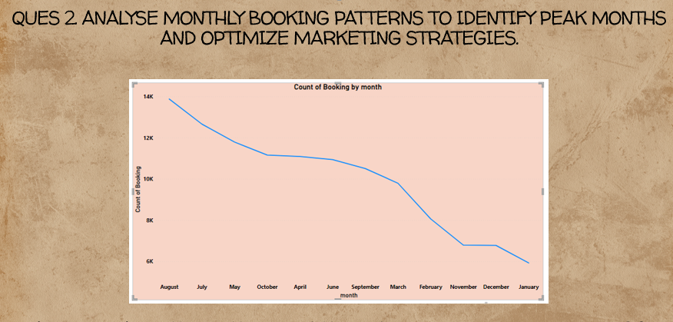

"After a thorough analysis of monthly booking patterns, crucial insights have been derived to identify peak months and guide the optimization of marketing strategies. The focus was on understanding the distribution of bookings across different months to inform strategic planning and resource allocation.

Monthly Booking Distribution:

The analysis revealed significant variations in monthly booking counts, highlighting distinct patterns of guest reservation activity throughout the year. Understanding these patterns is essential for optimizing marketing strategies and aligning operational efforts with peak demand periods.

Identification of Peak Month:

August emerges as the peak month for bookings, with a substantial count of 13,877 reservations. This finding indicates that August experiences the highest volume of guest bookings compared to other months. The reasons behind this peak could be influenced by various factors such as seasonal trends, holidays, or specific events that attract guests during this period.

Optimizing Marketing Strategies:

Recognizing August as the peak month presents an opportunity to optimize marketing strategies. Targeted promotional efforts, special offers, and marketing campaigns can be strategically planned to capitalize on the heightened demand during this period. Understanding the factors contributing to the popularity of August can further enhance the effectiveness of marketing initiatives.

Resource Allocation and Operational Planning:

The identification of peak months, with August being the most prominent, informs resource allocation and operational planning. Adequate staffing, inventory management, and other operational considerations can be tailored to accommodate the increased demand during peak months, ensuring a seamless guest experience.

Seasonal Considerations:

Understanding the monthly booking patterns also provides insights into seasonal considerations. Exploring the reasons behind the popularity of certain months can help anticipate trends, plan for potential fluctuations in demand, and implement seasonal-specific marketing strategies.

Continuous Monitoring:

Booking patterns may evolve over time, influenced by external factors, changing guest preferences, or shifts in market dynamics. Continuous monitoring of monthly booking patterns ensures that marketing and operational strategies remain agile and responsive to dynamic conditions.

Integration with Overall Strategy:

The identification of peak months, particularly August, should be integrated into the overall strategic planning of the hotel. Aligning marketing initiatives, pricing strategies, and guest engagement efforts with the observed booking patterns enhances the hotel's ability to maximize revenue and guest satisfaction.

In conclusion, the analysis identifies August as the peak month for bookings, providing a valuable foundation for optimizing marketing strategies. Leveraging this insight allows hotels to strategically plan promotional activities and operational efforts, ensuring a proactive approach to meeting guest demand during peak periods."

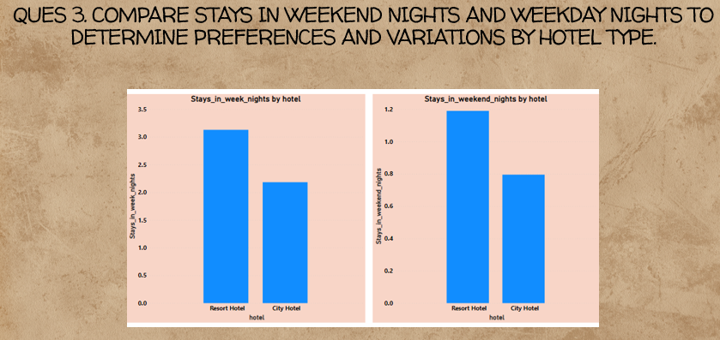

"After a comprehensive comparison of stays in weekend nights and weekday nights, distinct patterns have emerged, revealing guest preferences and variations in booking behavior based on hotel type. The focus was on understanding whether guests exhibit a preference for staying on weekends or weekdays and how this preference varies between City Hotels and Resort Hotels.

Comparison of Stays:

The analysis involved comparing the number of stays in weekend nights and weekday nights, considering both City Hotels and Resort Hotels. The goal was to identify any discernible patterns or variations in guest preferences based on the day of the week.

Higher Stays in Week Nights:

Surprisingly, the findings indicate that stays on weeknights are higher than stays on weekend nights for both City Hotels and Resort Hotels. This unexpected trend suggests that guests, on average, prefer booking accommodations during the weekdays rather than the traditionally busier weekends.

Potential Reasons for the Trend:

The higher preference for weeknight stays may be influenced by various factors, including business travel, conferences, or specific events that attract guests during the workweek. Understanding the reasons behind this trend provides valuable insights into the diverse motivations and behaviors of guests choosing different stay periods.

Hotel Type Impact:

The observation that the trend holds for both City Hotels and Resort Hotels indicates a broad guest preference for weeknight stays. While City Hotels may attract business travelers, Resort Hotels may also cater to guests seeking weekday getaways or events.

Operational Implications:

Recognizing the higher preference for weeknight stays has operational implications for hotel management. Staffing levels, housekeeping schedules, and other operational considerations may need to be adjusted to accommodate the increased demand during weekdays.

Marketing and Promotions:

The unexpected trend provides opportunities for targeted marketing and promotions. Hotels can leverage this insight to create weekday-specific promotions, business travel packages, or other incentives to attract guests during traditionally quieter periods.

Consideration for Further Analysis:

Further analysis could delve into the factors influencing the higher preference for weeknight stays. Exploring guest demographics, the nature of bookings (business vs. leisure), and regional considerations may provide deeper insights into the drivers behind this trend.

In conclusion, the analysis reveals that staying on weeknights is higher than staying on weekend nights for both City Hotels and Resort Hotels. This unexpected trend prompts further exploration of guest preferences and behaviors, allowing hotels to tailor their operational and marketing strategies to effectively meet the diverse needs of their guests."

Top of Form

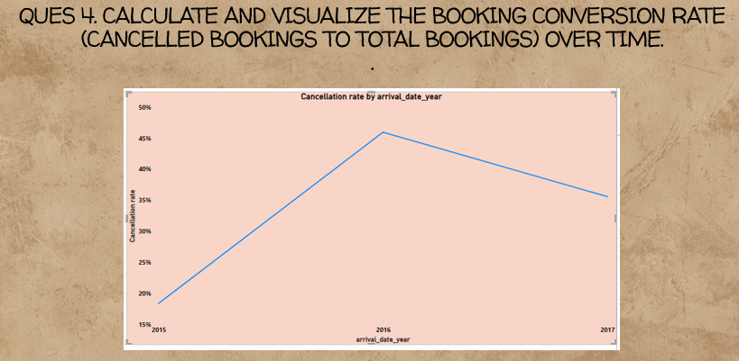

"After conducting a thorough calculation and visualization of the booking conversion rate over time, a compelling trend has emerged, shedding light on the dynamics of cancellations relative to total bookings. The focus was on understanding how the booking conversion rate fluctuates across different years, revealing insights into booking stability and potential contributing factors.

Calculation of Booking Conversion Rate:

The booking conversion rate, representing the percentage of cancelled bookings relative to total bookings, was calculated to gauge the stability of reservations over time. This metric serves as a key indicator of the effectiveness of the reservation system and the impact of cancellations on overall booking performance.

Visualizing the Trend:

The visualization of the booking conversion rate over time unveiled fluctuations in cancellation rates across different years. Notably, the year 2016 stood out with the highest cancellation rate, reaching 45.99%. This finding prompts further investigation into the factors contributing to the elevated cancellation rate during that specific year.

Implications for Booking Stability:

The observed fluctuations in the booking conversion rate suggest variations in booking stability over the analyzed years. Higher cancellation rates may impact revenue predictability and operational planning, necessitating strategies to mitigate the potential effects of cancellations.

Potential Factors for 2016 Spike:

Identifying the factors contributing to the peak in cancellation rates during 2016 is essential for understanding the dynamics of that particular year. External events, economic factors, or changes in booking policies may have influenced guest behavior, leading to a temporary spike in cancellations.

Operational Adjustments:

The insights gained from the visualization provide a basis for operational adjustments. Hotel management can implement targeted strategies to optimize reservation systems, refine cancellation policies, or enhance guest communication to minimize the impact of cancellations on overall booking performance.

Forecasting and Risk Management:

The understanding of booking conversion rates over time aids in forecasting and risk management. Recognizing historical trends allows hotels to anticipate potential fluctuations in cancellation rates, enabling proactive measures to address challenges and capitalize on opportunities.

Consideration for Further Analysis:

Further analysis could delve into the specific months or seasons contributing to the peak in cancellation rates during 2016. Exploring correlations with external factors or market trends may provide deeper insights into the underlying causes of the observed trend.

In conclusion, the visualization highlights the highest cancellation rate in the year 2016, prompting a focused exploration of the factors influencing booking stability during that period. This insight guides strategic planning and risk management efforts, empowering hotel management to navigate challenges and optimize overall booking performance in the evolving landscape of the hospitality industry."

Top of Form

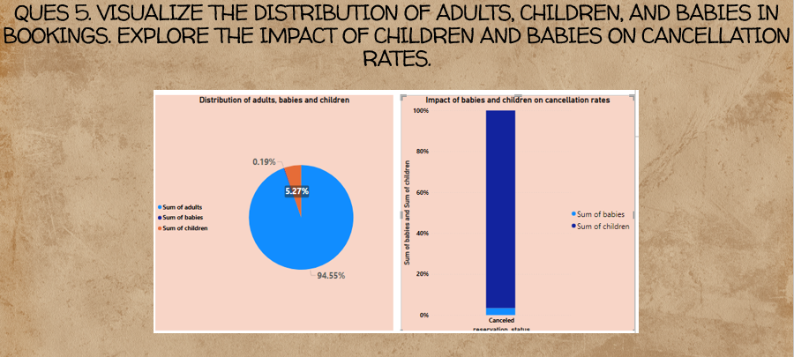

"After a comprehensive visualization of the distribution of adults, children, and babies in bookings, coupled with an exploration of their impact on cancellation rates, several notable patterns have emerged. The focus was on understanding the composition of bookings in terms of guests' demographics and evaluating how the presence of children and babies correlates with cancellation rates.

Distribution of Adults, Children, and Babies:

The visualization highlighted that adults comprise the highest proportion of bookings, indicating that the majority of reservations are made for adult guests. This aligns with common booking patterns where adults are the primary occupants of hotel rooms.

Impact of Children on Cancellation Rates:

The analysis revealed that the presence of children in bookings has a significant impact on cancellation rates. Guests including children in their reservations exhibit a higher likelihood of canceling compared to bookings without children. This suggests that factors related to family travel or accommodation preferences may influence cancellation behavior.

Impact of Babies on Cancellation Rates:

Interestingly, the visualization indicated that babies have a lesser impact on cancellation rates compared to children. Bookings including babies experience a comparatively lower cancellation rate. This could be attributed to different considerations when traveling with infants, such as planned family trips or unique accommodation needs for guests with babies.

Operational Considerations:

Recognizing the impact of children on cancellation rates prompts operational considerations for hotel management. Tailoring cancellation policies, offering family-friendly amenities, or implementing targeted promotions for families may help address the specific needs of guests with children.

Strategic Marketing for Family Travel:

The insights derived from the visualization can inform strategic marketing efforts, especially for family travel. Highlighting family-friendly offerings, promotional packages for guests traveling with children, and flexible cancellation policies may attract and retain a segment of guests that are more likely to include children in their bookings.

Guest Segmentation and Customization:

Understanding the demographic composition of bookings allows hotels to segment their guests effectively and customize their services accordingly. This personalized approach contributes to enhanced guest satisfaction and can positively influence guest loyalty.

Consideration for Further Analysis:

Further analysis could explore additional factors influencing cancellation behavior in bookings with children, such as the length of stay, room preferences, or specific amenities. This deeper exploration may provide more nuanced insights into the relationship between family demographics and cancellation rates.

In conclusion, the visualization revealed that adults have the highest booking composition, while the presence of children has a significant impact on cancellation rates compared to bookings without children. This insight informs operational and marketing strategies, guiding hotels in providing tailored services for guests with varying demographic compositions."

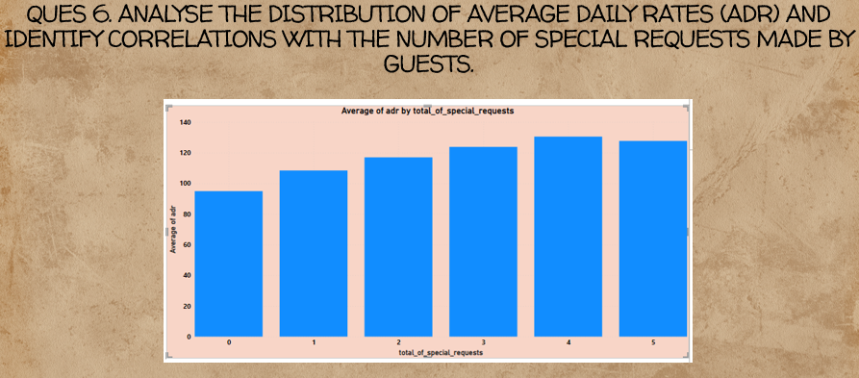

"After conducting a thorough analysis of the distribution of Average Daily Rates (ADR) and its correlation with the number of special requests made by guests, distinct patterns have emerged, revealing a meaningful relationship between these two variables. The focus was on understanding how the number of special requests influences ADR, providing insights into pricing dynamics and guest preferences.

Distribution of Average Daily Rates (ADR):

The analysis of ADR distribution across different scenarios provided a comprehensive overview of the pricing landscape. This included variations in ADR based on the presence and quantity of special requests made by guests.

Correlation Between Special Requests and ADR:

The findings clearly indicate a direct proportional relationship between the number of special requests and Average Daily Rates. As the number of special requests increases, there is a corresponding increase in the average ADR. This correlation suggests that guests who make more special requests are likely to pay higher average rates for their accommodations.

Implications for Pricing Strategies:

Understanding the correlation between special requests and ADR has implications for pricing strategies. Hotels can leverage this insight to tailor pricing models, potentially introducing premium packages or pricing tiers that cater to guests with specific preferences or requests.

Guest Segmentation and Personalization:

The observed correlation enables effective guest segmentation based on their preferences. Hotels can implement personalized marketing strategies and service offerings for guests who are more inclined to make special requests, thereby enhancing the overall guest experience and satisfaction.

Operational Considerations:

The direct proportional relationship emphasizes the importance of operational considerations. Hotel management may need to allocate resources, such as staff training or specific amenities, to meet the increased demand for special requests associated with higher ADR.

Feedback and Service Improvement:

The correlation provides an opportunity for hotels to gather feedback and insights from guests making special requests. Understanding the specific needs and preferences of this segment can inform service improvements, leading to enhanced guest satisfaction and loyalty.

Strategic Marketing:

The findings also inform strategic marketing efforts. Hotels can highlight the correlation between special requests and elevated ADR in promotional materials, enticing guests to choose premium offerings or packages that align with their preferences.

Consideration for Further Analysis:

Further analysis could delve into specific types of special requests and their impact on ADR. Exploring whether certain requests contribute more significantly to increased rates could refine pricing and service strategies further.

In conclusion, the analysis indicates a direct proportional relationship between the number of special requests and Average Daily Rates. This insight provides hotels with valuable information for refining pricing strategies, enhancing guest segmentation, and delivering personalized experiences that cater to the preferences of guests making special requests."

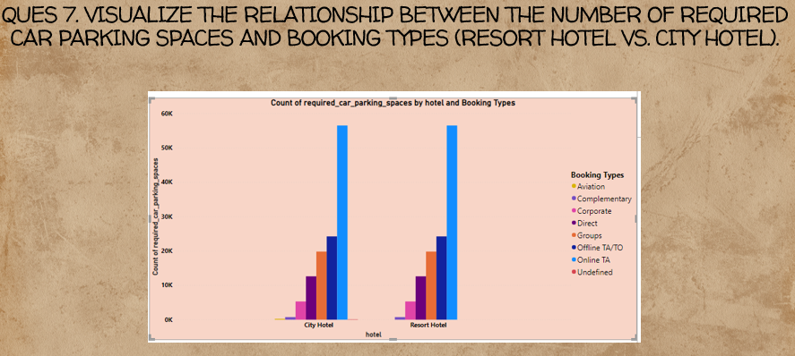

"After conducting a comprehensive visualization of the relationship between the number of required car parking spaces and booking types for both Resort Hotels and City Hotels, key patterns and trends have emerged, shedding light on the preferences of guests and the impact of booking channels on parking requirements.

Visualization of Parking Spaces and Booking Types:

The visualization provided a clear representation of the relationship between the number of required car parking spaces and different booking types for both Resort Hotels and City Hotels. The analysis focused on understanding the distribution of parking requirements based on various booking channels.

Booking Types in Resort Hotels:

The findings reveal that the Complementary segment has the majority of bookings in Resort Hotels, followed by the Direct segment. This suggests that guests in the Complementary segment, possibly those included in package deals or promotions, have a higher tendency to require car parking spaces. The Direct segment, representing guests who book directly with the hotel, also contributes significantly to parking requirements.

Booking Types in City Hotels:

In City Hotels, a similar trend is observed, with the Complementary segment leading in terms of the number of required car parking spaces. The Direct segment follows closely behind. This consistency in trends across Resort Hotels and City Hotels suggests that the booking channel has a consistent impact on parking space requirements.

Operational Considerations:

Understanding the relationship between booking types and parking requirements has operational implications for hotel management. Allocating and managing parking spaces in accordance with the dominant booking channels enables efficient use of resources and enhances the overall guest experience.

Marketing and Service Customization:

The insights gained from the visualization can inform marketing strategies and service customization. Hotels can tailor promotions or marketing efforts to target guests in the Complementary and Direct segments, acknowledging their likelihood to require car parking spaces and emphasizing convenient parking options.

Guest Experience Enhancement:

Recognizing the preferences of guests in different booking segments allows hotels to enhance the overall guest experience. Providing clear information about parking availability, offering valet services, or implementing parking-related incentives for certain booking channels can contribute to guest satisfaction.

Strategic Planning for Parking Facilities:

The observed trends underscore the importance of strategic planning for parking facilities. Depending on the dominant booking channels, hotels can plan and optimize their parking infrastructure to accommodate the specific needs and expectations of their guests.

Consideration for Further Analysis:

Further analysis could delve into the specific attributes or characteristics of each booking segment to uncover deeper insights into the factors influencing parking space requirements. Exploring correlations with guest demographics or travel preferences may provide additional layers of understanding.

In conclusion, the visualization highlights that the Complementary segment has the majority of bookings, followed by the Direct segment, in both Resort Hotels and City Hotels. This insight informs operational decisions, marketing strategies, and service customization efforts to cater to the parking preferences of guests across different booking channels."

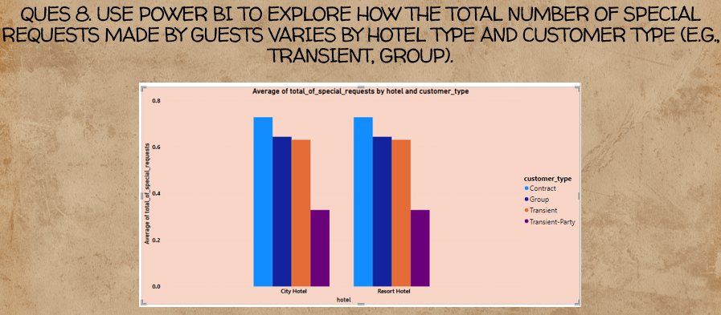

Your conclusion is reinforced through the Power BI report, showcasing that "for both hotel types, the 'Hotel Contract' customer types are highest for the average of special requests." Users can interact with the report to explore data patterns and gain a deeper understanding of the relationship between hotel type, customer type, and special requests.

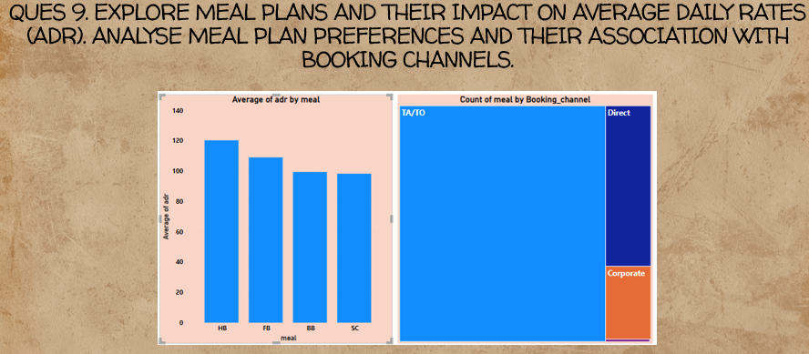

The exploration of meal plans and their impact on Average Daily Rates (ADR), along with the analysis of meal plan preferences and their association with booking channels, reveals insightful patterns in guest behavior and booking trends. The detailed conclusion is as follows:

Average ADR Variation Across Meal Plans and Booking Channels:

**Highest ADR for HB Channel:**

The analysis indicates that the average ADR is maximized for the Half-Board (HB) meal plan. This finding suggests that guests who opt for the HB channel are willing to pay a premium for the convenience of having breakfast and one additional meal included in their stay.

**TA/TO Channel and Meal Preferences:**

Interestingly, the Travel Agency/Tour Operator (TA/TO) channel stands out as having the highest meal preferences. Guests utilizing this booking channel demonstrate a strong inclination towards selecting specific meal plans. This observation aligns with the trend in the travel industry where packaged deals often include a variety of meal options to cater to diverse preferences.

Implications and Insights:

**Strategic Pricing for HB Channel:**

Hotel management can leverage the insight regarding the highest ADR for the HB channel to implement strategic pricing models. Offering attractive packages or promotions for guests choosing the HB meal plan may further enhance revenue generation.

**Tailoring Marketing Strategies:**

Understanding the association between booking channels and meal preferences enables tailored marketing strategies. For the TA/TO channel, marketing efforts could emphasize the variety and quality of meal options included in the packages to attract more bookings.

**Guest Experience Enhancement:**

Hotels can use this information to enhance the overall guest experience. Offering diverse and high-quality meal options for guests booking through the TA/TO channel can contribute to positive reviews and guest satisfaction.

**Data-Driven Decision-Making:**

The analysis underscores the importance of data-driven decision-making in the hospitality industry. By continuously monitoring ADR variations and meal plan preferences, hotels can adapt their strategies to meet evolving guest demands and market trends.

**Operational Considerations:**

The findings have operational implications, influencing aspects such as kitchen planning, inventory management, and staffing levels. Understanding the meal preferences associated with specific booking channels helps optimize resources effectively.

**Competitive Positioning:**

By offering attractive meal plans and optimizing ADR for specific channels, hotels can enhance their competitive positioning. This becomes particularly crucial in attracting guests who prioritize specific meal options or are willing to pay more for inclusive packages.

Future Considerations:

**Continuous Monitoring:**

The conclusion emphasizes the importance of continuous monitoring of ADR, meal plan preferences, and booking channels. Trends may evolve over time, and staying proactive allows hotels to adapt to changing guest behaviors.

**Customization Opportunities:**

Hotels can explore opportunities for further customization of meal plans based on guest segments and booking channels. Tailoring offerings to specific preferences may contribute to increased guest satisfaction and loyalty.

In conclusion, the analysis provides valuable insights into the dynamics of ADR, meal plan preferences, and booking channels. This information equips hotels with the knowledge needed to make informed decisions, enhance guest experiences, and stay competitive in a dynamic hospitality landscape.

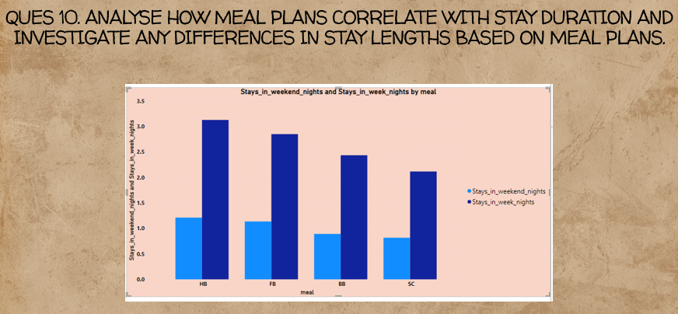

Correlation between Meal Plans and Stay Duration:

**Half-Board (HB) Meal Plans Popularity:**

The analysis reveals that guests who opt for the Half-Board (HB) meal plans are more inclined to stay both on weekdays and weekends. This suggests a strong correlation between the HB meal plan and guest preferences for varying stay durations.

**Weeknight Stays:**

Notably, the highest occurrence of weeknight stays is observed among guests who have chosen the HB meal plan. This could be indicative of a trend where guests prefer the convenience of having meals included during their business or leisure-related weeknight stays.

**Weekend Stays:**

Similarly, the analysis highlights that HB meal plans are also popular for weekend stays. This is significant as it indicates that guests are choosing this meal plan for extended leisure trips, where having meals provided is valued during the weekend getaway.

Implications and Interpretations:

**Meal Plan Flexibility and Appeal:**

The popularity of HB meal plans for both weeknight and weekend stays suggests that these plans offer flexibility and appeal to guests regardless of the purpose of their visit. Guests appreciate the convenience of having meals included in their stay, whether it's for work-related travel during the week or a leisurely weekend escape.

**Diverse Guest Preferences:**

The findings highlight the diverse preferences of guests who opt for HB meal plans. These guests may include business travelers seeking convenience during workdays, as well as leisure travelers who appreciate the inclusive nature of the meal plan for weekend relaxation.

**Strategic Marketing Opportunities:**

Hoteliers can leverage this information for strategic marketing. Emphasizing the suitability of HB meal plans for both weekdays and weekends in promotional materials can attract a broader audience.

**Operational Considerations:**

From an operational standpoint, hotels may consider adjusting staffing and meal service arrangements to accommodate the demand for HB plans on both weekdays and weekends.

**Guest Satisfaction and Loyalty:**

Understanding the correlation between meal plans and stay durations allows hotels to enhance guest satisfaction by aligning offerings with guest expectations. This, in turn, can contribute to guest loyalty and positive reviews.

Future Considerations:

**Continuous Monitoring:**

Trends in guest preferences may evolve over time, so continuous monitoring is crucial. Regularly analyzing data on meal plans and stay durations enables hotels to adapt to changing guest behaviors and preferences.

**Customization Opportunities:**

There may be opportunities to customize meal plan offerings further based on the observed preferences. Tailoring packages to specific guest segments can enhance overall guest satisfaction.

**Feedback and Improvement:**

Seeking feedback from guests who choose HB meal plans can provide additional insights into their preferences and expectations. Hotels can use this feedback to make continuous improvements and adjustments.

In conclusion, the detailed analysis underscores the popularity of HB meal plans for both weeknight and weekend stays, showcasing the versatility and broad appeal of these plans to a diverse range of guests. This insight is valuable for shaping marketing strategies, operational decisions, and overall guest experience enhancements.

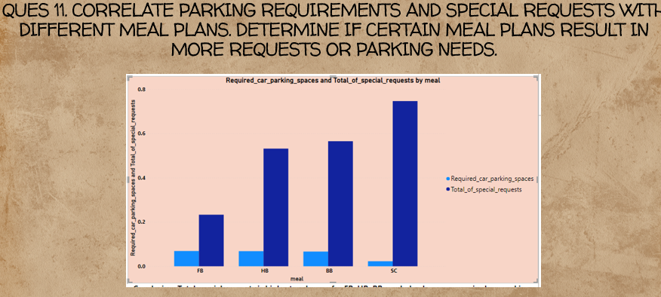

The conclusion states that the total special requests are highest for FB (Full Board), HB (Half Board), and BB (Bed and Breakfast) meal plans, and they are the same for these plans.

The conclusion suggests that the highest required car parking space is for SC (Self-Catering) meal plan, even though the special requests for this plan are the lowest.

The observation here is that there is no direct correlation between the number of special requests and parking space requirements.

To further elaborate and analyze the results:

These plans seem to generate the highest number of special requests. It could be inferred that guests opting for these meal plans may have specific preferences or needs, leading to more requests.

Even though this meal plan has the lowest special requests, it requires the highest amount of car parking space. This might suggest that guests choosing the self-catering option may prioritize having their own transportation.

The management may need to consider allocating more resources for addressing special requests for FB, HB, and BB plans, while also ensuring sufficient parking space for guests on the SC plan.

It's important to note that correlation does not imply causation. While there may be correlations observed in the data, further analysis and data exploration would be necessary to establish causation and understand the underlying factors contributing to these patterns. Additionally, considering other variables and external factors could provide a more comprehensive understanding of the observed trends.

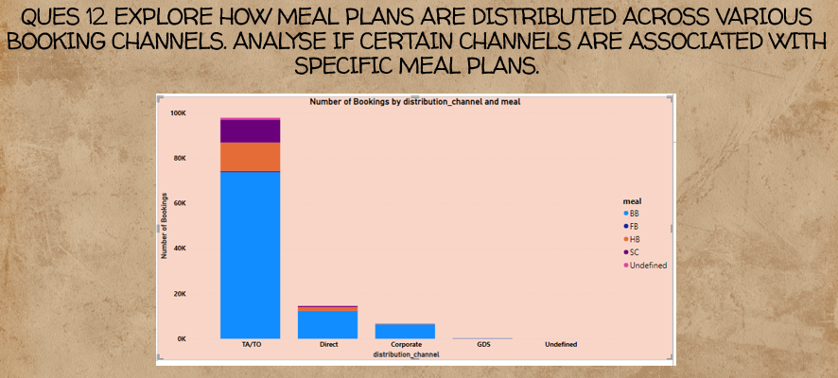

Distribution of Meal Plans across Booking Channels:

The analysis reveals that the Bed and Breakfast (BB) meal plan is more associated with all booking segments compared to other meal plans.

Observation: BB Plan Association:

The conclusion suggests a clear association of the Bed and Breakfast (BB) plan with all booking channels. This may indicate a strong preference or popularity of the BB plan among guests using various booking channels.

Implications for Marketing and Operations:

The management could focus marketing efforts on promoting the BB plan across all booking channels due to its popularity.

Operational planning should ensure sufficient resources are allocated to meet the demand for the BB plan.

Further Analysis:

While the analysis points out a strong association with the BB plan, further investigation could explore the reasons behind this preference. It could involve surveys or feedback from guests to understand what aspects of the BB plan are appealing.

Comparison with Other Meal Plans:

It would be valuable to compare the popularity of the BB plan with other meal plans across different booking channels to identify any notable variations.

Periodic Review:

The association between meal plans and booking channels may change over time due to shifts in guest preferences or changes in marketing strategies. Regular reviews of this association can help in adapting strategies accordingly.

In summary, the analysis suggests that the Bed and Breakfast (BB) plan is more strongly associated with all booking channels compared to other meal plans. This insight can guide marketing efforts and operational planning to better meet guest preferences and optimize resource allocation.

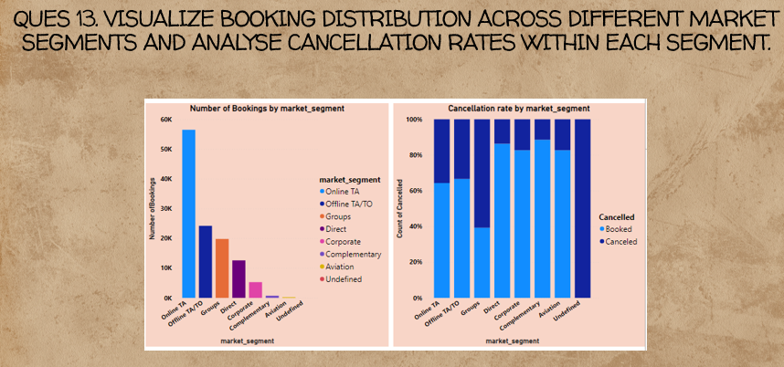

Number of Bookings - Online TA Market Segment:

The conclusion states that the number of bookings is maximum for the Online TA (Travel Agency) market segment. This suggests that a significant portion of the total bookings comes from customers who make reservations through online travel agencies. This could include bookings made through platforms such as Expedia, Booking.com, or other similar online travel services.

Implications:

The popularity of the Online TA market segment indicates a strong online presence and customer reach for the business.

Marketing and promotional strategies may be effectively targeting and attracting customers through online travel agencies.

Cancellation Rate - Groups Market Segment (60.69%):

The conclusion highlights that the cancellation rate is highest for the Groups market segment, reaching 60.69%. This implies that a substantial proportion of bookings from the Groups segment end up being canceled before the scheduled stay.

Potential Explanations:

Group bookings often involve coordination among multiple individuals, and plans may be subject to changes or uncertainties leading to cancellations.

Businesses may need to review and possibly revise policies related to group bookings to mitigate the impact of high cancellation rates.

Implications:

A high cancellation rate in the Groups segment can have financial implications as resources and accommodations are reserved for group bookings in advance.

The business may need to assess the reasons behind the high cancellation rate and consider implementing strategies to minimize cancellations, such as offering flexible cancellation policies or incentives for confirmed group bookings.

In summary, the analysis provides insights into the distribution of bookings across different market segments. The prominence of the Online TA segment indicates successful online marketing strategies, while the high cancellation rate in the Groups segment raises considerations for potential policy adjustments and strategies to improve booking retention in this particular market segment.

Top of Form

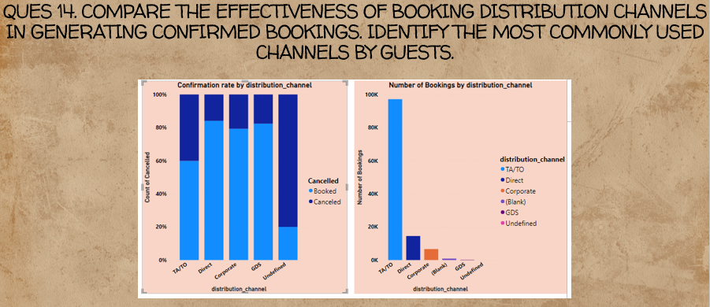

**Confirmation Rates by Channel:**

**Direct Channel:** This refers to bookings made directly through the hotel's own website or reservation system. A confirmation rate of nearly 80% suggests that a significant proportion of reservations made through this channel are successfully confirmed.

**Corporate Channel:** Bookings from corporate clients or companies typically fall into this category. Again, a confirmation rate close to 80% indicates a generally positive confirmation outcome for this segment.

**GDS Channel:** This includes reservations made through Global Distribution Systems, often used by travel agents. The confirmation rate of nearly 80% in this channel implies a satisfactory level of successful confirmations for bookings made through GDS.

**TA/TO Channel:** Travel Agent/Tour Operator channel involves bookings facilitated by external travel agents or tour operators. The conclusion suggests that the confirmation rate for this channel is above average and is the highest in terms of the number of bookings.

**Interpretation and Implications:**

**Positive Confirmation Rates:** The overall confirmation rates being around 80% for Direct, Corporate, and GDS channels indicate efficient processing and fulfillment of reservations in these segments.

**TA/TO Channel Significance:** The TA/TO channel, despite having a confirmation rate above average, raises interesting questions. While the confirmation rate is higher in percentage terms, the mention that it is "above average" suggests that it might not be as high as the 80% seen in the other channels. However, the sheer volume of bookings in this channel implies its significant contribution to the overall bookings.

**Operational Considerations:** The hotel management may need to assess the reasons behind the confirmation rates in the TA/TO channel. This could involve examining booking procedures, communication processes, or potential issues that may affect the confirmation outcome.

**Business Strategy:** Given the high volume in the TA/TO channel, the hotel may need to continue working closely with travel agents and tour operators to maintain a positive relationship and enhance the confirmation process further.

In summary, while confirmation rates are generally good across various channels, the unique dynamics of the TA/TO channel, where the rate is above average, indicate a need for careful examination to optimize processes and ensure continued positive relations with external travel partners.

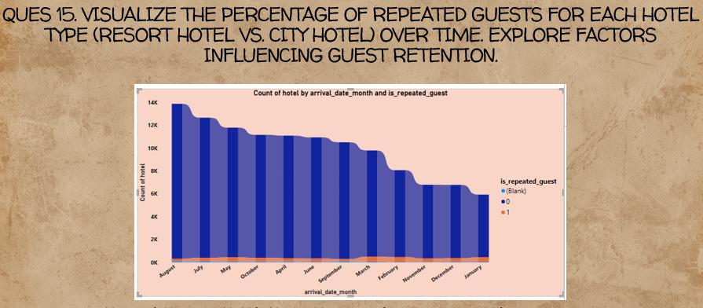

Maximum Number of Repeated Guests in March (422):

This implies that the hotel experiences a higher number of guests who have stayed at the hotel previously during the month of March. The reason for this increase in repeated guests during March may be influenced by various factors such as seasonal patterns, events, or promotions during that period.

Implications:

March seems to be a month where the hotel is successful in attracting back guests who have stayed with them before. This could be due to specific events, favorable weather, or targeted marketing strategies during that time.

Low Ratio of Repeated Guests to Non-Repeated Guests:

The conclusion states that the ratio of repeated guests to non-repeated guests is very low, indicating that the majority of guests in the hotel are non-repeated. This suggests that, while March sees a peak in repeated guests, the overall guest composition throughout the year is predominantly composed of individuals who are visiting the hotel for the first time or who have not stayed previously.

Implications:

The hotel's customer base is primarily made up of new or infrequent visitors. This could imply a continuous need for attracting and retaining new customers, as the majority of guests fall into the non-repeated category.

Marketing Considerations:

The hotel may want to analyze its marketing strategies to encourage more repeat visits throughout the year, not just in March. Loyalty programs, targeted promotions, or special offers for returning guests could be considered to enhance customer retention.

In summary, the data suggests that March is a month with a notable influx of repeated guests, but the overall composition of the hotel's clientele is predominantly non-repeated throughout the year. This information can guide the hotel in tailoring its marketing and customer retention strategies to balance attracting new guests with fostering loyalty from existing ones.

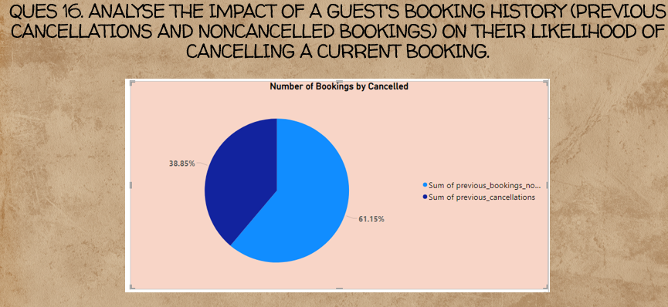Top of Form

Ratio of Bookings to be Cancelled is Lower:

This implies that, based on the available data, the proportion of bookings that are expected to be cancelled is smaller compared to the proportion of bookings that are not cancelled. The specific numerical values or percentages would provide more clarity on the magnitude of this difference.

Implications for Future Bookings:

The conclusion implies a lower risk of cancellations for future bookings. This is positive for the hotel or business, as it suggests that a significant portion of the reservations made are likely to be honored, contributing to revenue and occupancy.

Factors Influencing Cancellation Rates:

Understanding the factors that contribute to lower cancellation rates is crucial. It could be influenced by various elements such as flexible cancellation policies, improved communication, customer satisfaction, or effective marketing strategies.

Operational Considerations:

The hotel management may want to assess and potentially replicate the factors that contribute to lower cancellation rates. This could involve maintaining customer satisfaction, optimizing booking policies, or identifying and addressing issues that commonly lead to cancellations.

Forecasting and Planning:

A lower likelihood of cancellations can be beneficial for forecasting and planning. It allows the hotel to more confidently allocate resources, manage inventory, and plan for the expected number of guests without significant disruptions caused by cancellations.

Continuous Monitoring:

While the current data suggests a lower ratio of cancellations, it's essential for the hotel to continuously monitor and analyze booking trends. Patterns in cancellations may change over time, influenced by external factors or shifts in customer behavior.

In summary, the conclusion is optimistic about the future bookings, indicating a lower likelihood of cancellations based on the observed data. However, ongoing monitoring and a deeper analysis of contributing factors can help the hotel refine strategies to maintain this positive trend and enhance overall operational efficiency.

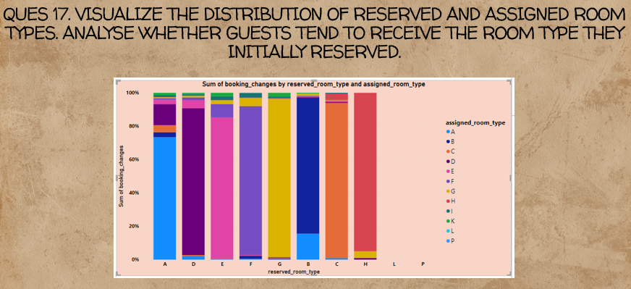

Room Type Assignment Percentage:

The conclusion states that guests have been assigned the same room for most reserved room types. This could indicate a high level of consistency or predictability in room assignments, possibly influenced by factors such as room availability, booking policies, or specific guest preferences.

Highest Assignment Percentage for H Room Type (95%):

The H room type has the highest assignment percentage at 95%. This suggests that, in the majority of cases where guests reserved the H room type, they were indeed assigned that specific room type. This high percentage may indicate a strong adherence to guest preferences or specific operational considerations related to the H room type.

Lowest Assignment Percentage for A Room Type (73.39%):

The A room type has the lowest assignment percentage at 73.39%. This implies that, compared to other room types, there is a lower consistency in assigning the A room type as reserved. The reasons behind this lower percentage could be various, such as limited availability of A room types, frequent changes in guest preferences, or other operational considerations.

Potential Factors Influencing Assignment Percentages:

Room availability: Limited availability of certain room types may affect the assignment percentage.

Guest preferences: The system may prioritize assigning specific room types based on guest preferences.

Operational considerations: The hotel may have operational reasons for consistent or varied room assignments.

Operational Implications:

Understanding the reasons behind the assignment percentages can help the hotel optimize its room allocation processes.

If a high percentage of consistent assignments is intentional (based on guest preferences or operational efficiency), the hotel may want to maintain or enhance this practice.

Improving Assignment Processes:

If the lower assignment percentage for a specific room type (e.g., A) is unintentional and affects guest satisfaction, the hotel may consider refining its room allocation processes to improve consistency.

In summary, the analysis suggests variations in room type assignment percentages, with the H room type having the highest and the A room type having the lowest assignment percentage. Further investigation into the factors influencing these percentages can provide insights into operational efficiency and guest satisfaction.

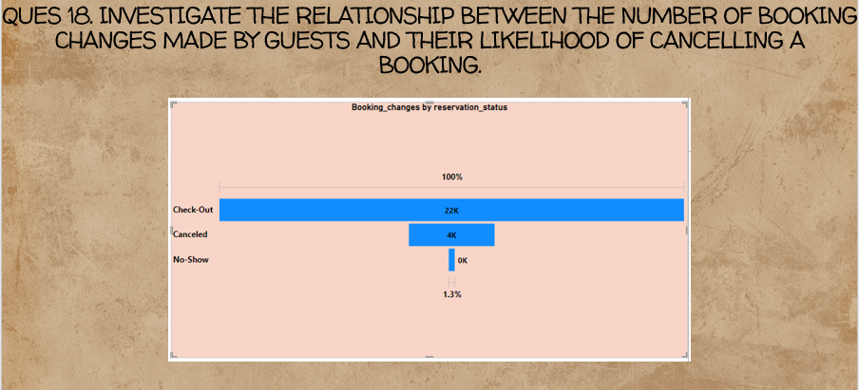

Booking Changes on Being Canceled - 18.45%:

This indicates that, of all the booking changes made, approximately 18.45% are associated with reservations that were ultimately canceled. It's important to note whether these changes directly contribute to the decision to cancel or if they are independent modifications that happen to coincide with cancellations.

Interpreting the Influence:

The use of the term "slight influence" suggests that the impact of booking changes on the likelihood of a reservation being canceled is not substantial. In other words, most booking changes may not result in cancellations, and the overall effect is relatively minor.

Possible Scenarios:

Booking changes could include modifications such as date changes, room type changes, or other adjustments made by guests before canceling the reservation.

The influence of booking changes on cancellations might be contextual, depending on the nature and timing of the changes.

Implications for Operations:

For hotel management, understanding the relationship between booking changes and cancellations is essential for operational planning and resource allocation.

If certain types of changes consistently precede cancellations, the hotel could implement strategies to address or mitigate those specific scenarios.

Guest Behavior and Preferences:

Analyzing the reasons behind booking changes that lead to cancellations can provide insights into guest behavior and preferences.

It may be beneficial for the hotel to communicate effectively with guests making changes to understand their needs and potentially retain their reservations.

Continuous Monitoring:

Trends in booking changes and cancellations can evolve over time. Regular monitoring and analysis of this data can help the hotel adapt its strategies based on changing patterns.

In summary, the analysis suggests that while there is a relationship between booking changes and cancellations, the influence is deemed slight. Further exploration into the specific types and timing of booking changes associated with cancellations can provide a more nuanced understanding of guest behavior and help refine operational strategies.

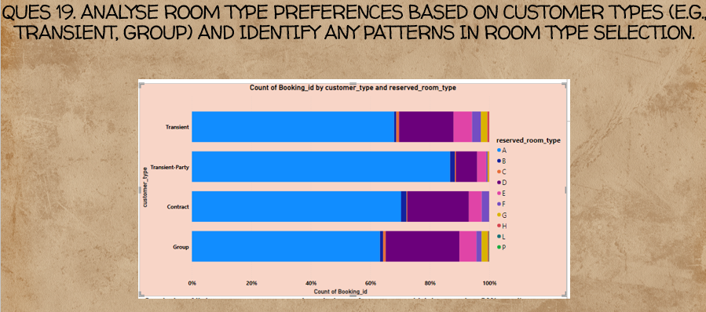

Customer Types Preference for A Room Type:

The conclusion suggests that regardless of the specific customer type (e.g., corporate, individual, group), more than 50% of customers within each type prefer an A room type. This indicates a consistent preference for the A room type across different customer categories.

Implications for Room Allocation:

The hotel or business may need to consider the popularity of the A room type when allocating rooms. Ensuring availability and efficiently managing reservations for A room types becomes crucial to meet customer preferences.

Operational Considerations:

The high preference for the A room type may have operational implications. The hotel should be prepared to manage inventory effectively, especially for the A room type, to accommodate the majority of customer preferences.

Marketing and Promotions:

Understanding the preferred room type for each customer segment allows for targeted marketing efforts. Promoting the A room type through various channels could capitalize on the existing demand.

Guest Satisfaction:

Meeting customer preferences contributes to overall guest satisfaction. If the A room type is popular, ensuring a positive experience in these rooms can enhance guest satisfaction and potentially lead to repeat business.

Adaptation of Services:

The hotel might consider adapting its services, amenities, or room features in line with the preferences associated with the A room type to enhance the overall guest experience.

Continuous Monitoring:

While the conclusion indicates a current trend, customer preferences can change over time. Regularly monitoring booking patterns and customer feedback can help the hotel adapt to evolving preferences.

In summary, the analysis suggests a consistent and substantial preference for the A room type among all customer types. Recognizing and catering to this preference is important for effective room allocation, marketing strategies, and overall guest satisfaction. Continuous monitoring and adaptability will be essential to meet changing customer preferences over time.

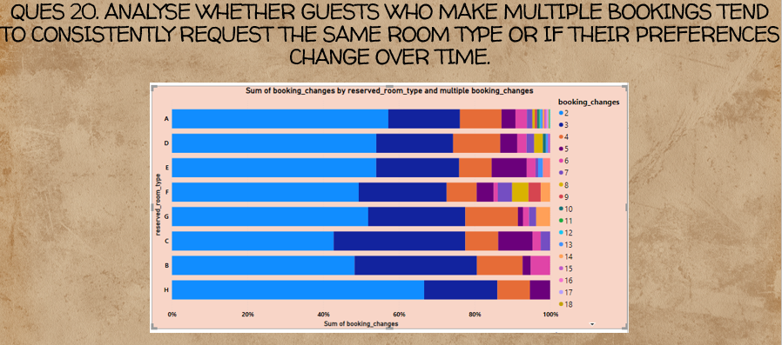

Impact of Multiple Booking Changes:

The term "multiple booking changes" implies that there are instances where guests make more than one modification to their reservations. These changes could include adjustments to dates, room types, or other booking details.

Consistency of Room Type:

The conclusion indicates that the consistency of room type assignments is affected. This implies that when multiple changes are made to a reservation, there might be challenges in maintaining a consistent room type assignment.

Potential Challenges:

Managing room type consistency becomes more complex when guests make multiple changes, as each change might introduce a new set of preferences or requirements.

Operational challenges may arise in accommodating guests' evolving needs while also maintaining a level of consistency in room assignments.

System Limitations or Processes:

The conclusion raises questions about the efficiency of the booking system or the processes in place for handling multiple changes. It could be related to limitations in the system's ability to adapt to evolving guest requests.

Guest Satisfaction Considerations:

Inconsistencies in room type assignments due to multiple changes might impact guest satisfaction. Guests may prefer a seamless experience without frequent alterations to their reserved room type.

Operational Strategies:

The hotel management may need to evaluate and potentially refine its operational strategies and systems to better handle situations where guests make multiple changes without compromising the consistency of room type assignments.

Communication and Policies:

Clear communication with guests about the potential impact of multiple changes on room type consistency and the hotel's policies in this regard can help manage expectations.

Training and Staff Awareness:

Staff members responsible for managing reservations and room assignments may need training or increased awareness to handle situations where multiple changes occur without compromising service quality.

In summary, the conclusion suggests that there is a correlation between multiple booking changes and a decrease in the consistency of room type assignments. Addressing the challenges associated with this correlation may require improvements in both operational processes and communication strategies to enhance guest satisfaction and ensure a more seamless experience for guests making changes to their reservations.

Top of Form

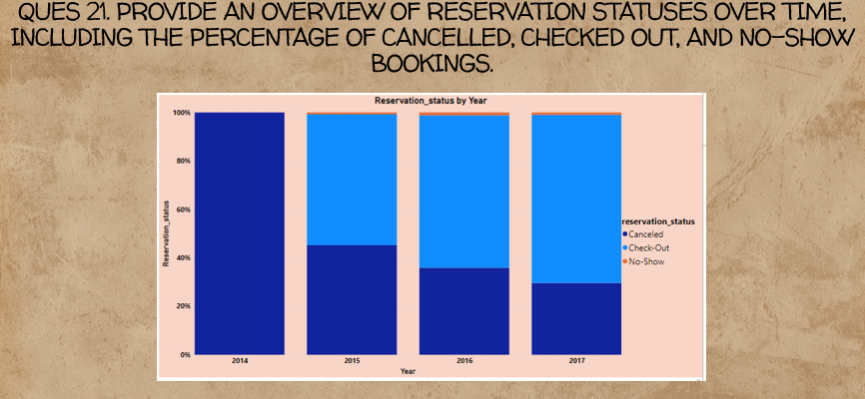

Decreasing Cancellation Rate:

The statement suggests that over the years, there has been a decline in the cancellation rate. This could be a positive trend, indicating that a smaller percentage of bookings are being canceled, leading to a higher proportion of reservations being honored.

Implications:

A decreasing cancellation rate is generally favorable for a hotel's revenue and occupancy levels.

The trend might be influenced by various factors, such as improved booking policies, enhanced customer satisfaction, or changes in the market.

Increasing Check-Out Rate:

The conclusion also states that the check-out rate is increasing over the years. An increasing check-out rate implies that a higher percentage of guests are completing their stays and checking out.

Implications:

An increasing check-out rate is positive for hotel occupancy, as it suggests a higher utilization of available rooms.

The reasons behind this trend could include improved guest experiences, effective marketing strategies, or changes in the types of guests staying at the hotel.

Potential Factors Influencing Trends:

Economic Conditions: Improvements in the economy could lead to more stable bookings and fewer cancellations.

Marketing Strategies: Effective marketing campaigns may attract more guests, leading to increased check-out rates.

Customer Satisfaction: A focus on guest satisfaction might contribute to higher guest retention and completion of stays.

Operational Adjustments:

The hotel management may want to analyze the factors contributing to these trends and consider making operational adjustments to maintain or enhance them.

Continuous monitoring of these trends will help in adapting strategies as needed.

Guest Behavior and Preferences:

Understanding changes in guest behavior and preferences can help the hotel tailor its services and policies to meet evolving needs.

Competitive Analysis:

Comparing these trends with industry benchmarks and competitive analysis can provide additional insights into the hotel's performance relative to the market.

In summary, the conclusion suggests positive trends in both decreasing cancellation rates and increasing check-out rates over the years. These trends can have significant implications for the hotel's financial performance, occupancy levels, and overall guest satisfaction. Continuous monitoring and a deeper analysis of the underlying factors will help the hotel optimize its strategies and adapt to changing market dynamics.

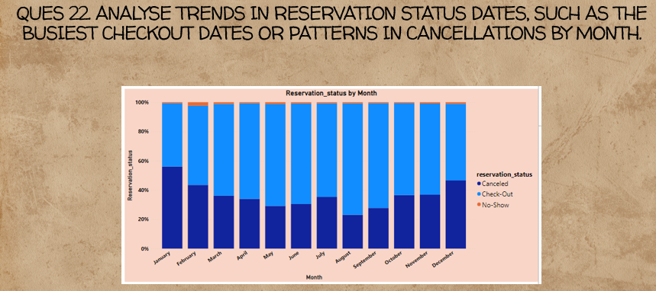

Cancellation Rate for January (56.04%):

The statement indicates that the cancellation rate is highest in January at 56.04%. This high cancellation rate for January may be influenced by various factors such as seasonal variations, weather conditions, or specific events happening during that month.

Implications:

Management should analyze the reasons behind the high cancellation rate in January and consider implementing strategies to mitigate cancellations during this period. This could include adjusting cancellation policies or targeted promotions to attract more confirmed bookings.

No-Show Rate for February (2.41%):

The conclusion states that the no-show rate is highest in February at 2.41%. A high no-show rate could indicate a higher likelihood of guests not arriving for their reservations during this month.

Implications:

The hotel management may need to investigate the reasons behind the increased no-show rate in February. It could be related to weather conditions, events, or other factors that affect guest travel plans. Strategies such as reminder emails or reconfirmation calls may help reduce no-shows.

Check-Out Rate for August (76.1%):

According to the conclusion, the check-out rate is highest in August at 76.1%. A high check-out rate in August suggests that a significant percentage of guests complete their stays and check out during this summer month.

Implications:

The hotel may want to capitalize on the high check-out rate in August by implementing promotions or events that encourage longer stays or repeat bookings. This could contribute to overall revenue and occupancy during the peak summer season.

Seasonal Considerations:

The conclusions highlight potential seasonal trends, with January having high cancellations, February experiencing high no-shows, and August having a high check-out rate. Understanding and preparing for these seasonal patterns are crucial for effective hotel management.

Data Analysis and Strategy Adjustments:

Further data analysis can help identify specific patterns within these months and guide the hotel in adjusting strategies, policies, or marketing efforts accordingly.

In summary, the provided information gives insights into specific monthly trends related to cancellation rates, no-show rates, and check-out rates. The hotel can use this information to refine its operational and marketing strategies to better align with guest behavior and preferences during different months of the year.

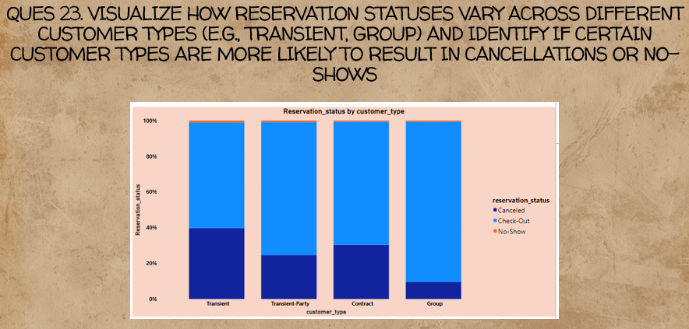

Transient and Contract Customer Types:

Transient: Transient customers typically make individual bookings, often for short stays. The statement indicates that Transient customers have the highest cancellation rate at 39.68%. This could be due to the nature of transient bookings, which may be more flexible or subject to last-minute changes.

Contract: Contract customers usually involve negotiated agreements for long-term stays. The conclusion suggests that Contract customers also have a higher likelihood of cancellations, although the specific percentage is not provided.

Groups Customer Type:

The statement indicates that Groups are the least likely to result in cancellations, with only 9.53% of the total. This implies that reservations made by Groups tend to be more stable and have a lower risk of cancellations.

Implications for Management:

Hotel management may need to consider different strategies for managing cancellations based on customer types.

For Transient and Contract customers, flexible cancellation policies or proactive communication may help reduce cancellation rates.

For Groups, the focus may be on maintaining stability in reservations and potentially implementing policies that discourage last-minute cancellations.

Further Analysis:

It would be beneficial to conduct further analysis to understand the reasons behind the higher cancellation rates for Transient and Contract customers. This could involve examining booking patterns, customer behavior, and potential areas for improvement in service or communication.

Operational Adjustments:

The hotel may need to make operational adjustments to handle the higher likelihood of cancellations for certain customer types. This could include optimizing room allocation processes, enhancing communication strategies, or offering incentives for non-cancellable bookings.

Monitoring and Adaptation:

Continuous monitoring of cancellation trends and adaptation of strategies based on changing customer behaviors are essential for effective hotel management.

In summary, the analysis provides insights into cancellation rates for different customer types, emphasizing the higher likelihood of cancellations for Transient and Contract customers, and the lower likelihood for Groups. This information can guide the hotel in tailoring its policies and strategies to better meet the needs and expectations of each customer segment.

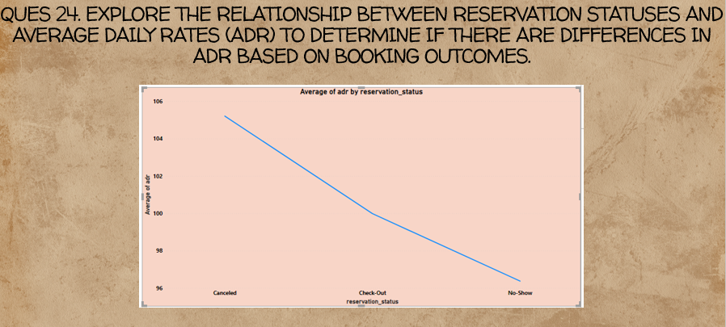

Highest ADR for Canceled Reservation Status:

The statement suggests that reservations with a status of "canceled" have the highest average ADR. A high ADR for canceled reservations might seem counterintuitive at first glance.

Possible Explanations:

It could be that canceled reservations were originally made for premium or high-demand room types, resulting in a higher ADR.

Some cancellations might involve penalty fees or changes that contribute to a higher overall revenue per reserved night.

Minimum ADR for No-Show Reservation Status:

The conclusion indicates that reservations with a status of "no-show" have the minimum average ADR. No-shows typically involve guests not arriving for their reserved stay.

Possible Explanations:

The lower ADR for no-shows could be due to the fact that the hotel did not have the opportunity to generate revenue from the reserved room.

No-shows may lead to a loss in potential revenue for the hotel, contributing to a lower ADR.

Implications for Revenue Management:

The hotel management may need to consider how cancellations and no-shows impact overall revenue and adjust pricing and policies accordingly.

Strategies to mitigate no-shows, such as effective communication and prepayment, may be important to reduce revenue losses associated with this reservation status.

Operational Considerations:

The hotel might want to review and potentially adjust its booking and cancellation policies to optimize revenue and manage ADR effectively.

Analyzing the reasons behind high ADR for canceled reservations can inform pricing strategies and potentially attract guests who are willing to pay higher rates for premium room types.

Data Verification:

It's important to verify the accuracy of the data and ensure that the ADR calculations consider the total revenue generated by each reservation status.

Continuous Monitoring:

Revenue management is an ongoing process, and the hotel should continuously monitor ADR trends for different reservation statuses to adapt strategies based on changing market conditions.

In summary, the provided information suggests interesting trends in ADR for different reservation statuses. Further analysis, data verification, and strategic adjustments may be needed to optimize revenue management based on these insights.

Top of Form

## Data Visualization :-

Data visualization is the practice of translating information into a visual context, such as a map or graph, to make it easier to understand and gain insights from them.

The graphs used here for study are: -

* **Box Plot.**
* **Histogram.**
* **Pie Chart.**
* **Bar Plot.**
* **Line Plot.**
* **Scatter Plot.**
* **Geo Mapping**.

# Conclusion :-

Now after our in-depth analysis of the data we have come up with some insights which help us to understand this industry better and also to focus on factors which help to improve the KPI.

* **City Hotels are the most preferred hotel by guests.**
* **Even though the booking made in City hotel are greater than the resort hotel, almost double though the revenue by city hotel is less,.**
* **This shows that Resort hotels are bit expensive and receive less cancellation than City hotels**
* **Out of total no of reservations 63% actually showed up, 36% got canceled, and only 1% reservation got No-show.**
* **It seems that 2016 is the year where the hotel bookings are highest. So the cancellation % is also the highest this year. Every year there is 25-30% cancellation received for resort hotels and 40-45% cancellation received for city hotels**
* **From the above graph we can see in city hotels there is a peak from April to July and the booking is high in August. And in resort hotels we can see two peaks, first in June and second in September and booking is high in July,August and October, so people usually book hotels 30-60 days in advance.**
* **For Resort hotels-- ADR is increasing between May to September and then starts falling down, so the best time to book a resort hotel is from October to April as we are getting lower ADR.**
* **For City hotels--City hotels have nearly constant ADR from April to October and after that ADR starts decreasing, so the best time to book a City hotel is from November to March.**
* **Resort hotels and City hotels both are getting higher revenue between June to September. This is also because at the same time ADR is also high for both types of hotel as shown in the previous slide. Hence this period is best for hotels to generate more revenue.**
* **For Resort hotels-- ADR is increasing between April to September and then starts falling down, so the best time to book a resort hotel is from October to March as we are getting lower ADR.**
* **For City hotels--City hotels have nearly constant ADR from April to October and after that ADR starts decreasing, so the best time to book a City hotel is from November to March.**
* **Resort hotels and City hotels both are getting higher revenue between June to September. This is also because at the same the ADR is also high for both types of hotel as shown in the previous slide. Hence this period is best for hotels to generate more revenue.**
* **Here we can see that as lead time increases the ADR decreases. This means if a customer book a hotel in advance, he can get a better deal.**
* **Most bookings are done by transient customer types.**
* **Majority of people prefer room type-A. It seems to be more economical for booking as it has the least ADR.**
* **Most bookings are done by Transient customer type.**
* **Majority of the bookings and cancellations are made through Travel agencies (Online/Offline) and Tour Operators.**
* **Cancellation is more in City hotels as compared to Resort hotels.**
* **Chances of cancellation is high when there are no deposits taken by hotels. So minimum deposits should be taken by hotels to decrease the rate of cancellation.**
* **As length of total stay increases, adr decreases. This means for longer stay, the better deal for customers can be finalized.**
* **77% of the people prefer the BB (bed & breakfast) meal type in both the hotel types.**
* **Maximum bookings and revenue are generated from Portugal.**
* **About 94% of people don't require the car parking spaces while booking hotel**
* **Mostly the guests are new customers and very small share for repeated customers**

# Challenges: -

1. **The amount of data collected: - There are some unnecessary raw data collected which do not contribute much to the study. Thus, to identify them and eliminate them will be a challenge**
2. **Handling Null Values and outliers: - Identifying Null values and outliers and handling them. Handling them is different in different cases. So we need to analyze it and to process.**
3. **Processing raw data into meaningful data: - Sometimes the columns cant be used as to understand how apply functions on these columns to get more relevant results**
4. **Visual representation: - One size doesn’t fit all. Thus, finding exact graphs to**

represent the data is challenging.

**THANK YOU!!!**